**OOP 期末專題**

Final Project

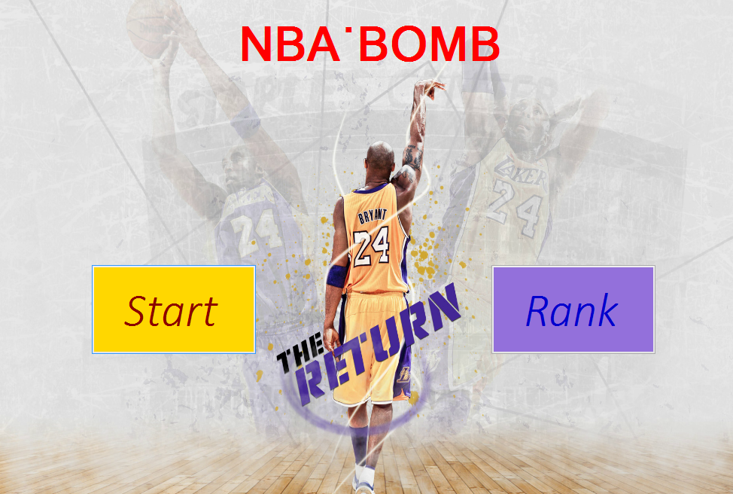**主題：**NBA‧BOMB

**作者**

108級電機B班0410746 林志恩

108級電機B班0410766 陳胤銓

**一、題目描述**

NBA炸彈超人 - 改良版 NBA‧BOMB

我們的構想是將大學生關注的NBA籃球運動融入炸彈超人的遊戲之中。

我們製作了人物選單，並事先選擇了十位NBA的籃球巨星，讓玩家可以從中選擇喜愛的角色遊玩本遊戲。此外，許多的背景圖也是利用像是Kobe Bryant、Michael Jordan、LeBron James的經典照片，讓遊戲充滿了NBA的氛圍。

**二、分工及每人負責的部分**

林志恩:

產生隨機地圖 --- O

計時器 --- O (利用計時器來製作player的行走控制、炸彈爆炸倒數、火

焰消失倒數、閃爍倒數、PUSH、Ready倒數等等)

放置炸彈 --- O

炸彈爆裂 --- O

產生特殊武器與道具 --- O

使用特殊武器與道具 --- O

角色設計 --- O (有十位不同的NBA球員可供選擇)

背景圖片與動畫 --- O (人物的大圖與小圖、每個panel的背景圖片，都

經過修圖美化並控制了大小)

Debug

程式優化

陳胤銓:

判斷鍵盤輸入 (2個player 的方向鍵與炸彈鍵) --- O

遊戲控制介面 (排版與選項) --- O (分成起始畫面、選角畫面、準備畫

面、遊戲畫面與排行榜)

電腦玩家行走路徑 (Artificial Intelligence) --- O (使用老鼠走迷宮的方

法)

電腦玩家移動 --- O

電腦玩家放置炸彈 --- O

判斷輸贏 --- O (最後贏家必須為一位Player1或Player2，如果只剩下電

腦玩家則輸掉遊戲)

設計關卡 (不同的遊戲模式) --- O (進入警告的倒數時間，地圖會慢慢

自動封閉，讓玩家的移動區域縮小)

排行榜 --- O (開檔案，可點擊Rank觀看紀錄)

Debug

程式優化

**三、使用的IDE**

Visual C#

**四、系統架構和分析**

有八個重點是我們自己原創的程式寫法，以下會一一說明：

1. Character (panel)：

點擊Start之後，panel就會切換到Character顯示在form中。我利用characterset把十個選角色用的picturebox初始圖片設好，並排到適當位置。一開始預設player1和player2選擇中間的角色，利用picturebox的paint在外圍畫出框框(player1：紅色、player2：藍色)，並利用timer讓框框的顏色閃爍，讓玩家知道現在是待選擇的狀態。經過keydown事件(和遊玩遊戲時一樣的操作方式，player1 移動W-A-S-D、選擇Space；player2移動上-下-左-右、選擇L)，改變selectindex1與selectindex2並經過換算，讓index所在的picturebox外框顯示紅色或藍色。在選角的過程中，會判斷是否下一項已被另外一個玩家選擇而跳過，因此兩位玩家並不會停留在同一角色，也不會選到一樣的角色。在keydown按下選擇鍵(L or Space)，那格的picturebox外框會停止閃爍，讓玩家知道已選擇此角色，如果另外一位玩家還沒選好角色，再按一次選擇鍵可以取消此角色去選其他角色。我們有找了NBA角色的大圖讓畫面更為豐富，也在旁邊加了label和一些圖示直接讓玩家瞭解如何操作。兩位玩家選完角色之後，兩位電腦玩家(CPU)會從剩下的八位角色隨機選取角色，而且不會重複選到同一角色。

1. Ready(panel)：

將玩家在Character選好的角色加上自動選好的電腦角色，一起顯示出來，並在中間說明等一下遊戲裡會出現的道具與其效果，讓玩家更容易上手這個遊戲。

下方則顯示Loading並倒數5秒鐘。

1. 玩家移動：

Player1 移動 W-A-S-D (上-下-左-右);

Player2 移動 上-下-左-右;

AI移動將在AI的部分做說明;

以player1來進行說明，當玩家按下W-A-S-D其中一個按鍵時觸發form1的

keydown事件 W-A-S-D (為了避免斜向移動，如果uptimer、downtimer、lefttimer、righttimer、timer1的enabled都是false，才進行以下步驟) 分別使uptimer、downtimer、lefttimer、righttimer四個方向的移動timer啟動，四個方向的timer經過一個週期(以向上為例)：預設是0.002秒會進行一次座標更新。

如果沒有撞到障礙物(判斷上方map的tag所存的值)：

player1.location = new point (player1.location.x,player1.location.y-step);

因為player1是picturebox，地圖則是用Game_paint事件畫出來的，所以picturebox移動的時候會自動觸發Game_paint，為了避免lag所以我們使用部分重劃的技巧(將在Game_paint進行說明)

停止移動:

(1) 撞到障礙物

(2) W按鍵放開，觸發keyup事件把uptimer關掉並啟動timer1(將player1移動到格子上面，避免人物處於格子之間) --> 關掉timer1

1. 產生地圖：

我們先將地圖的中間保留一個九宮格並設成通路，也將四個角落的角色起始位置設成通路。利用四次的for迴圈，先從地圖左上角的位置往九宮格的最左上角移動，計算好往右與往下還差幾步，隨機往四個方向移動一步，再改變往右和往下還差幾步的值，一直到兩者皆為0。其他三次for迴圈也為同理，而超界的部分我們也有做判斷，經過多次嘗試後完全沒有問題。再來我們就讓不能被炸的牆壁產生在不是通路的地方，這樣就不會擋到玩家，也不會讓玩家因此不能進行遊戲；而可以被炸的樹則是最後隨機產生在剩下的位置，我們有控制好牆壁和樹產生的數量與比例，並讓可以被炸的樹木裡有一定機率隱藏了特殊道具，只要玩家把樹炸開，就會顯示出來。

1. AI(CPU)：

在遊戲開始的時候啟動aitimer分別呼叫AI(0)和AI(1) (為player3和player4)，在AI函數中先呼叫aimapanalyze函數建構出AI目前能到達的地方存在aimap[i,j].pass裡面，在使用bombdanger將可到達且會被炸彈炸到的地方aimap[i,j].pass值改成2，再呼叫aimapvalue函數使用巢狀回圈計算每一個地圖位置的aimap[i,j].value 的值(不會到的地方value為負，會被炸到value會減小，能夠炸到樹或是人的地方value增加)，再來用巢狀回圈掃過15*15的aimap[i,j].value找出最大值得地方，存成goali, goalj(AI的目的地)，再來呼叫ratwalk函數使用老鼠走迷宮的方法(先宣告出一個15x15的二維陣列，將值都歸零，不能走的地方為-1，將所在位置的值+1之後，向四周最小值的地方走，每走一歨就存到路徑陣列裡面，當重複經過同依個地點時，會把多餘的路徑覆寫掉，變成最精簡的路徑)將路徑存成陣列，在aitimer下一次觸發的時候朝著路徑移動，當到達目的地時，放置炸彈，再次呼叫AI(0)，重新建構路徑。

1. 重劃:

在Game_paint裡面多寫了一些判斷式，只有剛進到遊戲介面的時候會全部畫一次，接下來判斷哪一個角色在移動，重劃角色周圍九宮格，而不是全部重劃，讓畫面能更流暢。

1. Warning (警告時間)兩分鐘以內:

地圖從左下角開始一格一格填滿，逆時針繞兩圈，當人物被地圖壓到時，血量就會直接歸零，從遊戲裡出局。先設定一個方向變數和要填滿的座標：當t%10==0也就是經過一秒鐘的時候呼叫fillin()函數，使用switch(方向變數)更新要填滿的座標(當座標通過x=y這條直線，把方向變數從向右改成向上)，再呼叫Game_paint事件把紅色磚頭劃出來。

1. Rank (panel)：

在遊戲結束後，如果玩家獲得勝利，將會動態產生一個Inputbox給玩家輸入名字，按下OK之後新增或開啟在Rank資料夾下的檔案寫入名字、playnum、生命值、炸彈數、花費時間。在切換Rank介面的時候把資料從檔案讀出，存成結構陣列，再把結構陣列依照花費時間進行排序 (sort)，並輸出到Rank裡面的label上顯示出來。

**函數原型(共6個檔案)**

1. Ready_function.cs

private void readyset() //設定Ready panel的位置、picturebox圖片設置

2. Rank.cs

public void fileopen(int playi, int life, int bomb, int lefttime, string namepass)//寫入檔案

public void fileread()//從檔案讀取

public void ranksort(int n)//將讀取的結構陣列依照時間排序

3. Inputbox.cs

private InputBox()//初始化

public String getValue()//傳回名字

public static bool Show(String title, String inputTips, bool isPassword, ref String value)//產生輸入視窗

private void Ok_Click(object sender, EventArgs e)//確認名字輸入

private void Cancel_Click(object sender, EventArgs e)//取消輸入

4. Game_function.cs

private void setimage()//設定圖片

private void setvalue()//設定初值

private void generate_map()//產生隨機地圖

public void bombvalue(int playernum, int x, int y, ref int index)//產生炸彈並設初值

public void bombsplash(int i, int j, int mapi, int mapj)//計算炸彈爆炸範圍

public void firetoroad(int i, int j, int mapi, int mapj)//把火焰變成一般路面

public void uirefresh()//更新介面

public void player1_specialitem(int playernum, int item)//角色1撿起特殊道具

public void player2_specialitem(int playernum, int item)//角色2撿起特殊道具

public bool iswaymove(int playno, int index, int direction)//判斷炸彈能不能被推動

private void AI(int aino)//用來呼叫有關ai的函數

public void aimapanalyze(int aino,int i,int j)//用遞迴建構出ai可到的地圖

public void bombdanger(int aino)//偵測地圖上哪個點會被炸到

public void aimapvalue(int aino)//設定aimap.value的值

public bool ratwalk(int aino,int aiy,int aix,int goaly,int goalx))//ai走的路徑(老鼠走迷宮)

public void detectbomb(int aino)//ai偵測周圍炸彈剩餘秒數

public bool setbomb(int aino)//判斷要不要放炸彈(AI)

public void isdied()//判斷遊戲勝負

public void gameclose()//關閉遊戲

public void fillmap()//warning 時間 將地圖縮小

5. Form1.cs

public Form1()

private void Form1_Load(object sender, EventArgs e)

private void button1_Click(object sender, EventArgs e) //Start按鈕，切換到Character的panel

private void button2_Click(object sender, EventArgs e) //Rank按鈕，切換到Rank的panel

private void Game_Paint(object sender, PaintEventArgs e)//控制遊戲畫面重劃

private void uptimer_Tick(object sender, EventArgs e)//控制往上移動

private void downtimer_Tick(object sender, EventArgs e))//控制往下移動

private void righttimer_Tick(object sender, EventArgs e)//控制往右移動

private void lefttimer_Tick(object sender, EventArgs e)//控制往左移動

private void timer1_Tick(object sender, EventArgs e)//將角色修正到正確位置

private void uptimer2_Tick(object sender, EventArgs e)//控制往上移動

private void downtimer2_Tick(object sender, EventArgs e))//控制往下移動

private void righttimer2_Tick(object sender, EventArgs e))//控制往右移動

private void lefttimer2_Tick(object sender, EventArgs e))//控制往左移動

private void timer2_Tick(object sender, EventArgs e)//將角色修正到正確位置

private void Form1_KeyUp(object sender, KeyEventArgs e)//偵測鍵盤放開

private void Form1_KeyDown(object sender, KeyEventArgs e)//偵測鍵盤按下

private void bombtimer_Tick(object sender, EventArgs e)//計算炸彈存在時間

private void mutekitimer_Tick(object sender, EventArgs e) //控制被火焰炸到後的無敵時間(Player 1)

private void mutekitimer2_Tick(object sender, EventArgs e) //控制被火焰炸到後的無敵時間(Player 2)

private void mutekitimer3_Tick(object sender, EventArgs e) //控制被火焰炸到後的無敵時間(CPU 1)

private void mutekitimer4_Tick(object sender, EventArgs e) //控制被火焰炸到後的無敵時間(CPU 2)

private void bombmovetimer_Tick(object sender, EventArgs e) //控制PUSH推炸彈的時間

private void aitimer_Tick(object sender, EventArgs e)//控制ai移動

private void gametimer_Tick(object sender, EventArgs e)//記算遊戲時間

private void warning_Paint(object sender, PaintEventArgs e)//劃出warning圖示

private void readytimer_Tick(object sender, EventArgs e) //控制Ready panel的維持時間，時間到進入Game panel

private void button3_Click(object sender, EventArgs e) //從Rank panel返回Main panel(主畫面)

6. Character.cs

private void characterset() //將picturebox初始圖片設置、位置設置

private void selecttimer_Tick(object sender, EventArgs e)//控制紅色與藍色外框的閃爍

private void Character_Paint(object sender, PaintEventArgs e)//讓十位角色的外框重劃

private void charactera3_Paint(object sender, PaintEventArgs e) //分別重劃自己的外框、判斷為紅色或藍色或無顏色

private void characterb3_Paint(object sender, PaintEventArgs e) //分別重劃自己的外框、判斷為紅色或藍色或無顏色

private void charactera1_Paint(object sender, PaintEventArgs e) //分別重劃自己的外框、判斷為紅色或藍色或無顏色

private void charactera2_Paint(object sender, PaintEventArgs e) //分別重劃自己的外框、判斷為紅色或藍色或無顏色

private void charactera4_Paint(object sender, PaintEventArgs e) //分別重劃自己的外框、判斷為紅色或藍色或無顏色

private void charactera5_Paint(object sender, PaintEventArgs e) //分別重劃自己的外框、判斷為紅色或藍色或無顏色

private void characterb1_Paint(object sender, PaintEventArgs e) //分別重劃自己的外框、判斷為紅色或藍色或無顏色

private void characterb2_Paint(object sender, PaintEventArgs e) //分別重劃自己的外框、判斷為紅色或藍色或無顏色

private void characterb4_Paint(object sender, PaintEventArgs e) //分別重劃自己的外框、判斷為紅色或藍色或無顏色

private void characterb5_Paint(object sender, PaintEventArgs e) //分別重劃自己的外框、判斷為紅色或藍色或無顏色

流程圖：

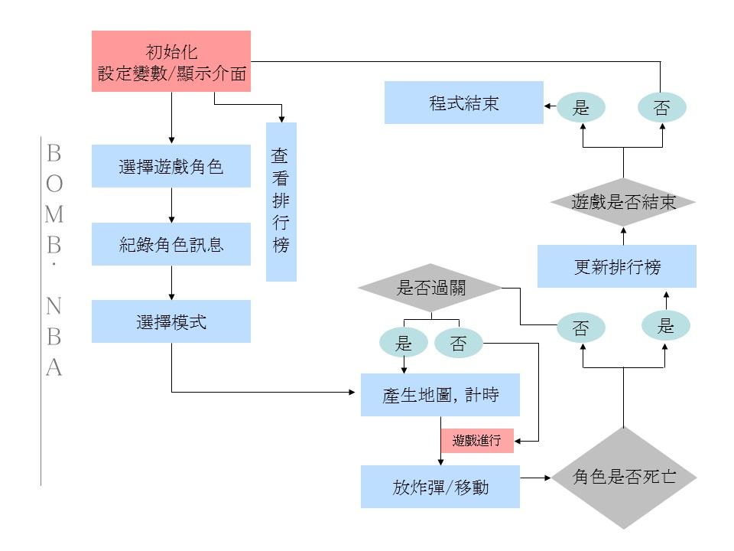

架構：

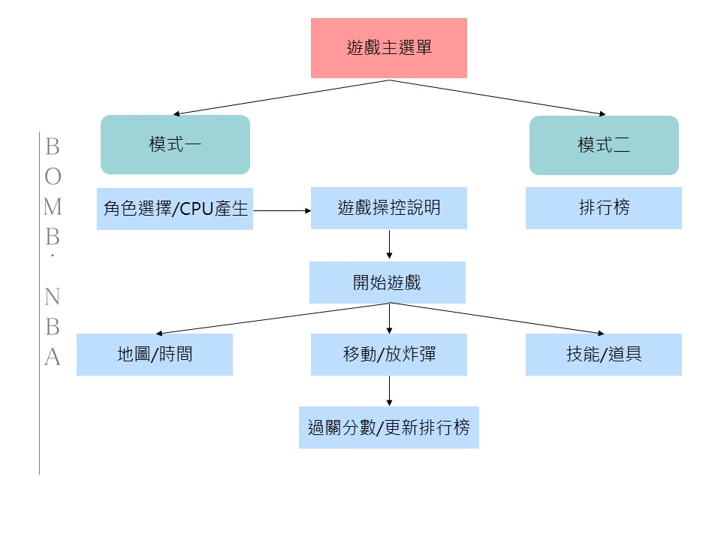

**五、執行結果**

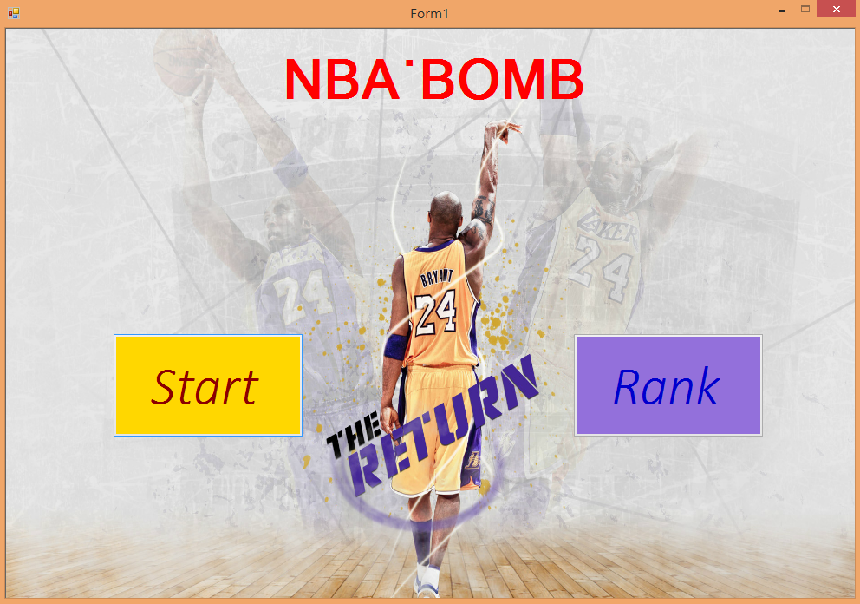

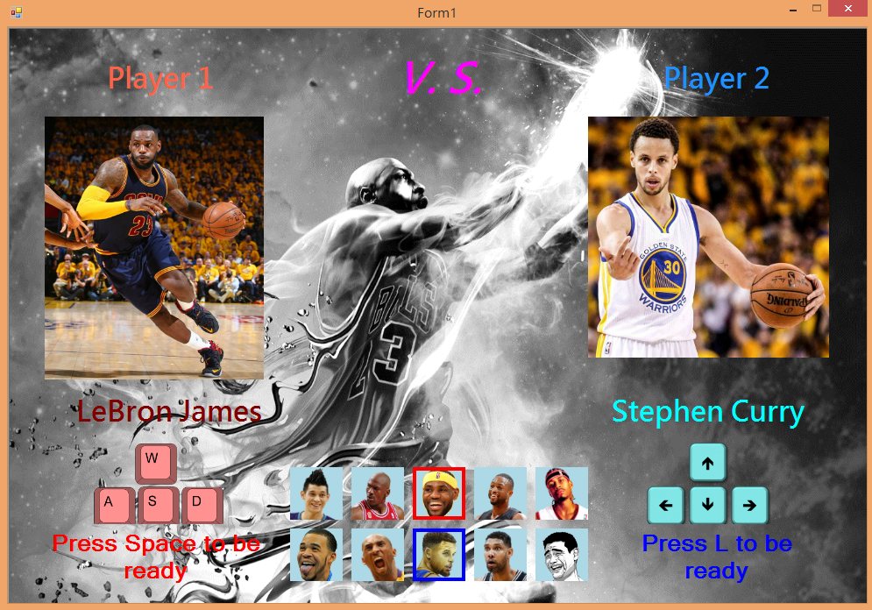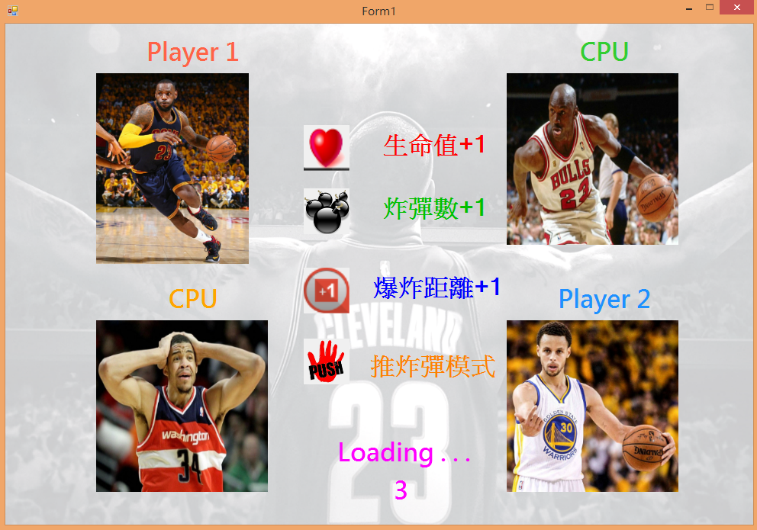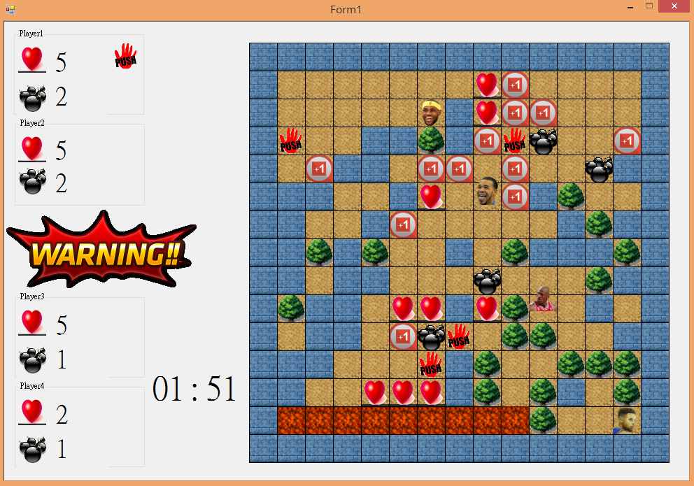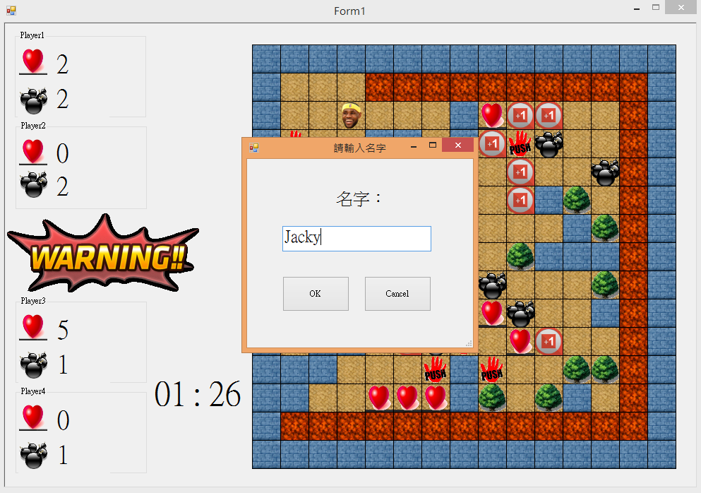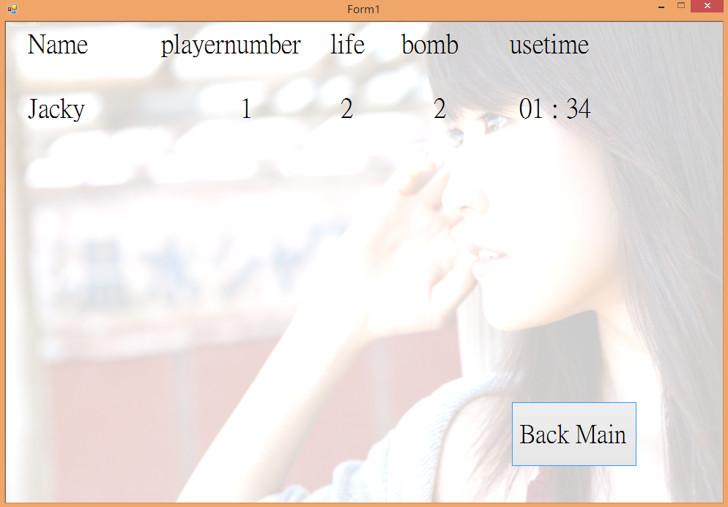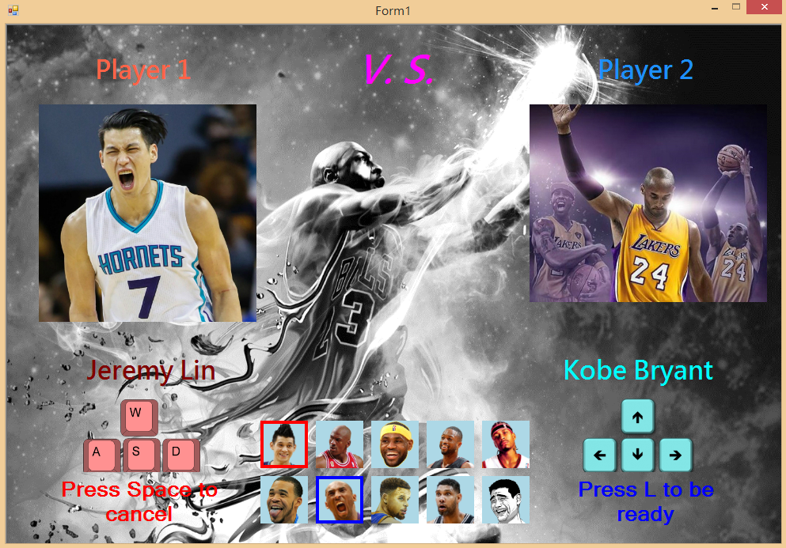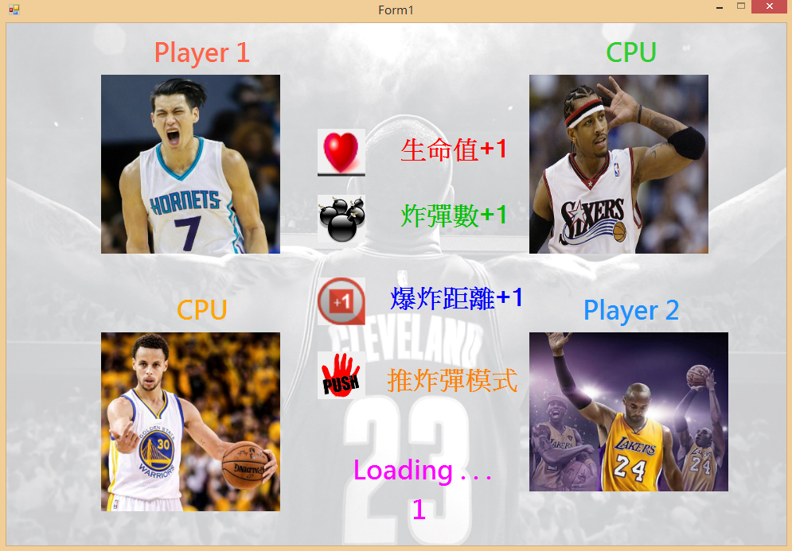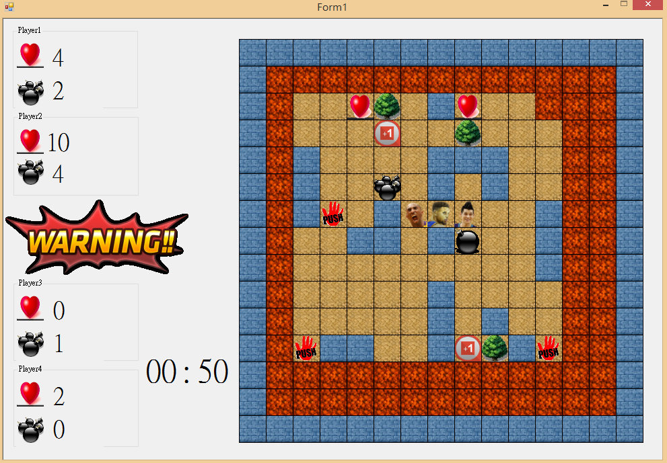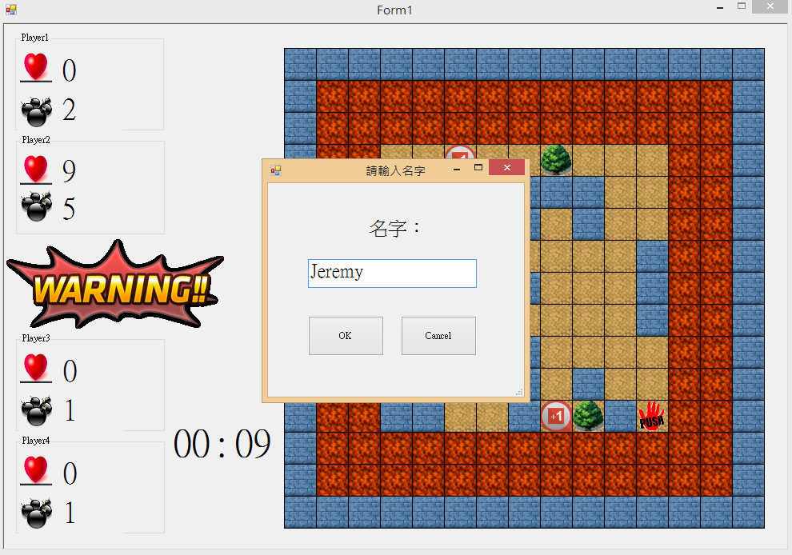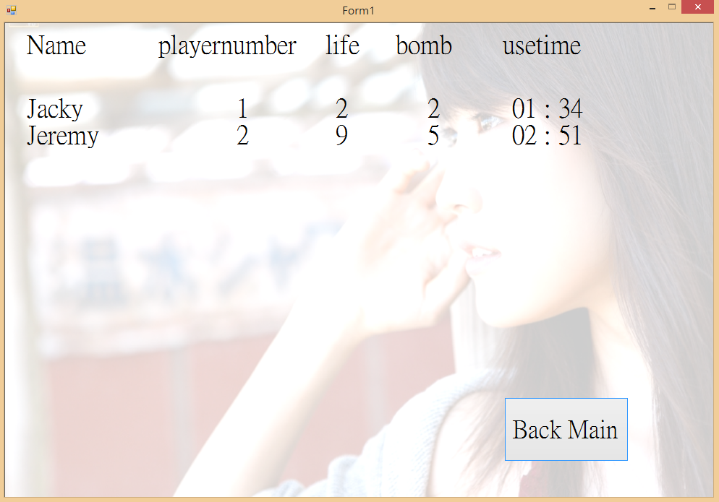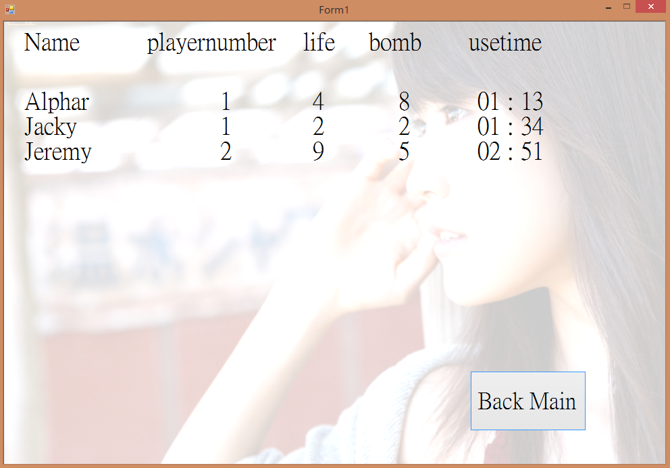

**六、心得報告: 遇到的問題，如何解決或結果分析**

(一) 問題與解決方式：

1. 在產生人物選單時發現會有一個picturebox異常變色，經過多次測試和觀察，推測出應該是指標指向物件的部分寫錯了，之後經過修正就變正常了，並使我們再次仔細檢查。

2. 鍵盤控制一開始是寫在keydown事件裡面，每一下鍵盤敲擊都會觸發移動，當放開的時候啟動timer1移動到正確的格子上，但是這個方法會讓速度不一致，而且程式碼會有冗長的判斷，且畫面看起來卡卡的。經過思考後，我們決定使用keydown觸發四個方向的移動timer，keyup的時候觸發timer1移動到正確的格子上，這樣不但讓程式少了30行，而且畫面更順暢更容易管理。

3. 一開始我們使用15*15的picturebox當作地圖，但是會導致人物以及炸彈圖片的透明化很難處理，後來把地圖直接畫在panel上面，人物以picturebox來顯示，接下來只要把picturebox.background設成transparent就可以了，但是這樣反而會讓人物移動的時候變lag，會有閃爍的問題。

4. 閃爍的問題:

之前人物畫在panel上後，我們發現人物在行走上會有閃爍的問題，我們利用在上機時，助教用心教大家的”DoubleBuffered”來解決。但問題在於，我們作畫的panel並沒有屬性讓我們直接使用，而是透過上網查詢大量資訊並一步步證實，讓我們得知在Form1加上少許程式碼，便能讓我們遊戲畫面的panel擁有”DoubleBuffered”的效果，也因而解決了人物在行走上的閃爍問題。

程式碼如下：

if (System.Windows.Forms.SystemInformation.TerminalServerSession)

return;

System.Reflection.PropertyInfo aProp =

typeof(System.Windows.Forms.Control).GetProperty(

"DoubleBuffered",

System.Reflection.BindingFlags.NonPublic |

System.Reflection.BindingFlags.Instance);

aProp.SetValue(Character, true, null);

aProp.SetValue(Ready, true, null);

aProp.SetValue(Game, true, null);

aProp.SetValue(warning, true, null);

5. Keydown事件的問題:

之前想要把Player2放置炸彈鍵設置為Enter，可是Keydown無法偵測到Enter按鍵，推測可能是因為有其他控件產生的干擾。詢問助教後，發現其實只要另外使用別的按鍵就行，不必拘泥在這種小地方，因此我們最後決定使用按鍵L。

6. 預測AI路徑的時候，使用遞迴產生路徑，一直遇到陣列超界的問題。

→ 使用老鼠走迷宮的方法，使用while迴圈處理就OK了。

1. 推炸彈的時候畫面會lag 。

→ 使用部分重劃就解決了這個問題，不必讓整張地圖重劃。

1. AI移動會lag。

→ 使用部分重劃就解決了這個問題，不必讓整張地圖重劃。

1. 開檔的時候會當掉。

→ 把檔案刪掉重建就OK。

1. Rank排版會有問題，容易亂掉。

→ 分成多個label比較整齊。

(二) 心得分享：

林志恩：

這次的OOP期末專題真的是經歷了重重考驗，從一開始構思到開始製作，常常覺得是不是把題目訂得太難，有想要放棄的念頭，但是我們熬過來了，不僅將我們的專題完成，寫了3182行的code，也入選了決賽，最後拿到優等的佳績。這段路程收穫最大也學習最多的一定是我們自己，除了將上課所學的東西融會貫通，還要自己想辦法將idea付諸實行，遇到困難要懂得發問並找尋辦法解決。看到最後執行的結果，心裡真的是非常有成就感，想到一切的努力與辛苦終於化成甜美的果實，不禁潸然淚下，感動萬分。

陳胤銓：

這次的專題克服了很多困難，還有燃燒了許多的期末考成績總算順利的完成，也在決賽獲得了優等的佳績，雖然還有很多目標還沒有完成，兩個人一起移動的時候有機率會lag，傳送點也尚未完成，期待在這個暑假能夠補完應該完成的進度，並且讓AI能夠更聰明有效率的去攻擊玩家。在寫排行榜的部份，才讓我第一次了解檔案原來是這樣應用的，目前是把資料全部讀到結構陣列裡面再排序輸出到螢幕上(效率不太好)，應該要另外建一個index的檔案來輔助使用增加效率，避免重複執行排序。

**七、參考書籍**

Google等網路資訊

助教在Lab所教的內容與其上課的檔案

同學指點並自己融會貫通

諸如：panel的Doublebuffered使用方法、重劃後背景的透明問題、picturebox的paint方法(畫外框)等等。

**八、Source code**

****************************************Ready_function.cs***********************************

using System;

using System.Collections.Generic;

using System.ComponentModel;

using System.Data;

using System.Drawing;

using System.Linq;

using System.Text;

using System.Threading.Tasks;

using System.Windows.Forms;

namespace NBA_BOMB

{

public partial class Form1 : Form

{

int readyload; //5秒

private void readyset()

{

Ready.BackgroundImage = new Bitmap(Properties.Resources.Ready_1000);

readyload = 5;

readytime.Text = readyload.ToString();

readytimer.Enabled = true;

}

}

}

********************************************Rank.cs*******************************************

using System;

using System.Collections.Generic;

using System.ComponentModel;

using System.Data;

using System.Drawing;

using System.Linq;

using System.Text;

using System.Threading.Tasks;

using System.Windows.Forms;

using System.IO;

namespace NBA_BOMB

{

public partial class Form1 : Form

{

struct ranktype

{

public string name;

public int playnum;

public int life;

public int bomb;

public int lefttime;

};

ranktype[] data = new ranktype[30];//可存30筆資料

public void fileopen(int playi, int life, int bomb, int lefttime, string namepass)

{

if (namepass == "")

return;

BinaryWriter outFile = new BinaryWriter(File.Open("..//..//Rank//Rank.dat", FileMode.Append));

outFile.Write(namepass); // 寫入 字串

outFile.Write(playi); // 寫入 整數

outFile.Write(life); // 寫入 整數

outFile.Write(bomb); // 寫入 整數

outFile.Write(lefttime); // 寫入 整數

outFile.Close(); // 關閉檔案

}

public void fileread()

{

Ranktitle.Text = "Name playernumber life bomb usetime\n\n";// 文字方塊 先清空

Rankname.Text = "";

ranklabel.Text = "";

if (!File.Exists("..//..//Rank//Rank.dat"))

return;

BinaryReader inFile = new BinaryReader(File.Open("..//..//Rank//Rank.dat", FileMode.Open));

int rankindex = 0;

/*String my_name;

int my_playi;

int my_life;

int my_bomb;

int my_lefttime;*/

while (inFile.BaseStream.Position < inFile.BaseStream.Length) // 傳回下一個可供使用的字元，但不消耗它

{

data[rankindex].name = inFile.ReadString(); // 讀出 字串

data[rankindex].playnum = inFile.ReadInt32();

data[rankindex].life = inFile.ReadInt32();

data[rankindex].bomb = inFile.ReadInt32();

data[rankindex].lefttime = inFile.ReadInt32();

rankindex++;

}

ranksort(rankindex);

ranklabel.Text = "";

Rankname.Text = "";

int min;

int sec;

for (int i = 0; i < rankindex; i++)

{

Rankname.Text = Rankname.Text + data[i].name + "\n";

ranklabel.Text = ranklabel.Text + (data[i].playnum + 1).ToString() + " ";

ranklabel.Text = ranklabel.Text + data[i].life.ToString() + " ";

ranklabel.Text = ranklabel.Text + data[i].bomb.ToString() + " ";

min = data[i].lefttime / 60;

sec = data[i].lefttime % 60;

if (min < 10)

ranklabel.Text = ranklabel.Text + "0";

ranklabel.Text = ranklabel.Text + min.ToString() + " ";

ranklabel.Text = ranklabel.Text + ": ";

if(sec<10)

ranklabel.Text = ranklabel.Text + "0";

ranklabel.Text = ranklabel.Text + sec.ToString();

ranklabel.Text = ranklabel.Text + Environment.NewLine;

}

inFile.Close(); // 關閉檔案

}

public void ranksort(int n)

{

ranktype tmp;

for (int i = 0; i < n; i++)

{

for (int j = i + 1; j < n; j++)

{

if (data[j].lefttime < data[i].lefttime)

{

tmp = data[i];

data[i] = data[j];

data[j] = tmp;

}

}

}

}

}

}

*************************************** *****Inputbox.cs***************************************

using System;

using System.Collections.Generic;

using System.ComponentModel;

using System.Data;

using System.Drawing;

using System.Linq;

using System.Text;

using System.Threading.Tasks;

using System.Windows.Forms;

namespace NBA_BOMB

{

public partial class InputBox : Form

{

private InputBox()

{

InitializeComponent();

}

public String getValue()

{

return textBox1.Text;

}

public static bool Show(String title, String inputTips, bool isPassword, ref String value)

{

InputBox ib = new InputBox();

if (title != null)

ib.Text = title;

if (inputTips != null)

ib.label1.Text = inputTips;

if (ib.ShowDialog() == DialogResult.OK)

{

value = ib.getValue();

ib.Dispose();

return true;

}

else

{

ib.Dispose();

return true;

}

}

private void Ok_Click(object sender, EventArgs e)

{

Form1.name = getValue();

if (Form1.name != "")

this.Close();

else

MessageBox.Show("空");

}

private void Cancel_Click(object sender, EventArgs e)

{

Form1.name = "";

this.Close();

}

}

}

**************************************Game_function.cs**************************************

using System;

using System.Collections.Generic;

using System.ComponentModel;

using System.Data;

using System.Drawing;

using System.Linq;

using System.Text;

using System.Threading.Tasks;

using System.Windows.Forms;

namespace NBA_BOMB

{

public partial class Form1 : Form

{

public static string name;

Pen myPen = new Pen(Color.Black, 1);

Bitmap scr = new Bitmap(1000, 700);

PictureBox[] play = new PictureBox[4];

const int num = 15;//17*17 地圖

const int topy = 30;//左上角y值

const int leftx = 350;//左上角x值

const int mapwidth = 40;//寬度

const int mapheight = 40;//高度

const int step = 4;//控制移動速度(40的因數)

const int aistep = 4;//控制移動速度(40的因數)

const int bombnum = 10;

const int bombattacknum = 2;

const int mutekitimerload = 20; //被炸彈炸到的無敵時間長度

const int pushtimerload = 50;

const int ainum = 2;

const int playnum = 2;

const int warnwidth = 272;

const int warnheight = 112;

const int warnt = 1200;//warning倒數時間 120秒

const int aiwaymax = 300;//aiway陣列大小

Bitmap scr1 = new Bitmap(warnwidth, warnheight);

int t = 1800; //遊戲時間

int warindex = 0;

bool[] movingflag = new bool[ainum];

int[] aiindex = new int[ainum];

int btomi, btomj;

int[] aidirection = new int[ainum];

int warni, warnj, warndirection;

//int player1_x = 1;

//int player1_y = 1;

Image pass = new Bitmap(Properties.Resources.brownground);

Image trash = new Bitmap(Properties.Resources.tree4);

Image notpass = new Bitmap(Properties.Resources.icewall);

Image bomber = new Bitmap(Properties.Resources.bomb01);

Image fire = new Bitmap(Properties.Resources.onfire);

Image warnwall = new Bitmap(Properties.Resources.redground);

Image[] tool = new Image[10];

Image[] war = new Image[6];

Random fixRand = new Random();

public struct maptype

{

public int x;

public int y;

public int tag;

public int item;

public bool fire;

public int firetoroadflag;

public int bombplayer;

public int bomblocationindex;

public bool warn;

};

public struct bombtype

{

public int x;

public int y;

public int timesec;

public int distance;

public bool exist;

public int onfire;

public int bombdirection; //上：1 ; 左：2 ; 下：3 ; 右：4

};

public struct playertype

{

public int playernum;

public int x;

public int y;

public int bombindex;

public int bombdistance;

public int bombcount;

public int mutekitime;

public int life;

public int direction; //上：1 ; 左：2 ; 下：3 ; 右：4

public int pushtime;

};

public struct aimaptype

{

public int pass;

public int value;

public int ratvalue;

public int timesec;

};

public struct aiwaytype

{

public int valuex;

public int valuey;

};

public struct wayindextype

{

public int index;

public int success;

public int direct;

public int back;

};

maptype[,] map = new maptype[num, num];

bombtype[,] bomb = new bombtype[4, bombnum];

playertype[] player = new playertype[4];

aimaptype[,,] aimap = new aimaptype[ainum, num, num];

aiwaytype[,] aiway = new aiwaytype[2, aiwaymax];

wayindextype[] wayindex = new wayindextype[2];

private void setimage()

{

tool[0] = new Bitmap(Properties.Resources.brownground);

tool[1] = new Bitmap(Properties.Resources.bomb14);

tool[2] = new Bitmap(Properties.Resources.love);

tool[3] = new Bitmap(Properties.Resources.push);

tool[4] = new Bitmap(Properties.Resources.distance);

war[0] = new Bitmap(Properties.Resources.war1);

war[1] = new Bitmap(Properties.Resources.war2);

war[2] = new Bitmap(Properties.Resources.war3);

war[3] = new Bitmap(Properties.Resources.war4);

war[4] = new Bitmap(Properties.Resources.war5);

war[5] = new Bitmap(Properties.Resources.war6);

}

private void setvalue()

{

warni = 13;

warnj = 0;

warndirection = 4;//1:上,2:左,3:下,4:右

t = 1800;

play[0] = player1;

play[1] = player2;

play[2] = player3;

play[3] = player4;

for (int i = 0; i < 4; i++)

play[i].Visible = true;

for (int i = 0; i < num; i++)

for (int j = 0; j < num; j++)

{

map[i, j].x = leftx + j * mapwidth;

map[i, j].y = topy + i * mapheight;

map[i, j].tag = 0;

map[i, j].item = 0; //沒有特殊道具

map[i, j].fire = false;

map[i, j].firetoroadflag = 0;

map[i, j].warn = false;

}

for (int i = 0; i < 4; i++)

{

player[i].playernum = i + 1;

player[i].bombindex = 0;

player[i].bombdistance = 1;

if (i >= 2)

player[i].bombcount = 1;

else

player[i].bombcount = bombattacknum;

player[i].life = 5;

player[i].mutekitime = mutekitimerload;

player[i].pushtime = 0;

switch (i)

{

case 0:

player[i].x = 1;

player[i].y = 1;

break;

case 1:

player[i].x = 13;

player[i].y = 13;

break;

case 2:

player[i].x = 13;

player[i].y = 1;

break;

case 3:

player[i].x = 1;

player[i].y = 13;

break;

default:

break;

}

}

for (int i = 0; i < 4; i++)

for (int j = 0; j < bombnum; j++)

{

bomb[i, j].x = -1;

bomb[i, j].y = -1;

bomb[i, j].distance = 1;

bomb[i, j].timesec = -1;

bomb[i, j].exist = false;

bomb[i, j].onfire = -1;

bomb[i, j].bombdirection = 0;

}

for (int i = 0; i < ainum; i++)

for (int j = 0; j < num; j++)

for (int k = 0; k < num; k++)

{

aimap[i, j, k].pass = 0;

aimap[i, j, k].value = 0;

aimap[i, j, k].ratvalue = 0;

}

for (int i = 0; i < 2; i++)

{

wayindex[i].index = 0;

wayindex[i].success = 0;

wayindex[i].direct = 0;

wayindex[i].back = 0;

for (int j = 0; j < aiwaymax; j++)

{

aiway[i, j].valuex = 0;

aiway[i, j].valuey = 0;

}

}

for (int i = 0; i < ainum; i++)

{

aiindex[i] = 0;

movingflag[i] = false;

}

for (int i = 0; i < ainum; i++)

aidirection[i] = 0;

}

private void generate_map()

{

//起始=0, 通(沙路)=-1, 不通(冰牆)=-2, 樹=1, 玩家起始位置四角=-3 ,炸彈=2

int[,] x = new int[num, num];

for (int a = 0; a < num; a++)

for (int b = 0; b < num; b++)

{

if (a == 0 || a == num - 1 || b == 0 || b == num - 1 || (a == (num - 1) / 2 && b == (num - 1) / 2)) //不通=-2

x[a, b] = -2;

else if ((a == (num - 1) / 2 - 1 || a == (num - 1) / 2 || a == (num - 1) / 2 + 1) && (b == (num - 1) / 2 - 1 || b == (num - 1) / 2 || b == (num - 1) / 2 + 1)) //通=-1

x[a, b] = -1;

else

x[a, b] = 0; //起始=0

}

int tmp, rc, dc, lc, indexx, indexy;

for (int i = 0; i < 4; i++)

{

if (i == 0 || i == 1)

{

if (i == 0)

{

indexx = 1;

indexy = 1;

rc = (num - 1) / 2 - 2;

dc = (num - 1) / 2 - 2;

}

else

{

indexx = 8;

indexy = 8;

rc = (num - 1) / 2 - 2;

dc = (num - 1) / 2 - 2;

}

while (rc != 0 || dc != 0)

{

tmp = fixRand.Next(0, 4);

switch (tmp)

{

case 0: //right

if (rc > 0)

{

x[indexy, indexx + 1] = -1;

indexx++;

rc--;

}

break;

case 1: //down

if (dc > 0)

{

x[indexy + 1, indexx] = -1;

indexy++;

dc--;

}

break;

case 2: //left

if (dc > 0 && rc > 0 && rc != 5)

{

x[indexy, indexx - 1] = -1;

indexx--;

rc++;

}

break;

case 3: //up

if (dc > 0 && rc > 0 && dc != 5)

{

x[indexy - 1, indexx] = -1;

indexy--;

dc++;

}

break;

}

}

}

else

{

if (i == 2)

{

indexx = 13;

indexy = 1;

lc = (num - 1) / 2 - 2;

dc = (num - 1) / 2 - 2;

}

else

{

indexx = 6;

indexy = 8;

lc = (num - 1) / 2 - 2;

dc = (num - 1) / 2 - 2;

}

while (lc != 0 || dc != 0)

{

tmp = fixRand.Next(0, 4);

switch (tmp)

{

case 0: //left

if (lc > 0)

{

x[indexy, indexx - 1] = -1;

indexx--;

lc--;

}

break;

case 1: //down

if (dc > 0)

{

x[indexy + 1, indexx] = -1;

indexy++;

dc--;

}

break;

case 2: //right

if (dc > 0 && lc > 0 && lc != 5)

{

x[indexy, indexx + 1] = -1;

indexx++;

lc++;

}

break;

case 3: //up

if (dc > 0 && lc > 0 && dc != 5)

{

x[indexy - 1, indexx] = -1;

indexy--;

dc++;

}

break;

}

}

}

}

x[1, 1] = -3; x[1, 13] = -3; x[13, 1] = -3; x[13, 13] = -3; x[1, 2] = -3; x[2, 2] = -3; x[13, 2] = -3; x[12, 2] = -3; x[1, 12] = -3; x[2, 12] = -3; x[13, 12] = -3; x[12, 12] = -3;//玩家起始位置四角=-3

int count = 0;

for (int i = 1; i < num - 1; i++)

for (int j = 1; j < num - 1; j++)

if (x[i, j] == 0)

count++;

int m;

int n;

for (int i = 0; i < Convert.ToInt64(count / 2); i++)

{

do

{

m = fixRand.Next(1, num - 1);

n = fixRand.Next(1, num - 1);

}

while (x[m, n] != 0);

x[m, n] = -2;

}

count = 0;

for (int i = 1; i < num - 1; i++)

for (int j = 1; j < num - 1; j++)

if (x[i, j] == 0 || x[i, j] == -1)

count++;

for (int i = 0; i < Convert.ToInt64(count / 5*3); i++)

{

do

{

m = fixRand.Next(1, num - 1);

n = fixRand.Next(1, num - 1);

}

while (x[m, n] != 0 && x[m, n] != -1);

x[m, n] = 1;

}

for (int i = 1; i < num - 1; i++)

for (int j = 1; j < num - 1; j++)

if (x[i, j] == 0)

x[i, j] = -1;

x[1, 1] = -1; x[1, 13] = -1; x[13, 1] = -1; x[13, 13] = -1; x[1, 2] = -1; x[2, 2] = -1; x[13, 2] = -1; x[12, 2] = -1; x[1, 12] = -1; x[2, 12] = -1; x[13, 12] = -1; x[12, 12] = -1;//玩家起始位置四角=-1

int randnum;

for (int i = 1; i < num - 1; i++)

for (int j = 1; j < num - 1; j++)

{

if (x[i, j] == 1)//樹的地方放特殊道具

{

randnum = fixRand.Next(0, 1001);

if (randnum >= 0 && randnum <= 300)

map[i, j].item = 0;//沒有特殊道具

else if (randnum > 300 && randnum <= 400)

map[i, j].item = 1;//炸彈數增加

else if (randnum > 400 && randnum <= 550)

map[i, j].item = 2;//補血

else if (randnum > 550 && randnum <= 700)

map[i, j].item = 3;//推炸彈

else

map[i, j].item = 4;//增加炸彈範圍

}

}

for (int a = 0; a < num; a++)

for (int b = 0; b < num; b++)

map[a, b].tag = x[a, b];

}

public void bombvalue(int playernum, int x, int y, ref int index)

{

/*int countexitst = 0 ;

for(int i=0;i<bombnum;i++)

if

*/

bombtimer.Enabled = true;

if (map[(y - topy) / mapheight, (x - leftx) / mapwidth].tag != 2)

{

bomb[playernum - 1, index].exist = true;

bomb[playernum - 1, index].distance = player[playernum - 1].bombdistance;

bomb[playernum - 1, index].x = x;

bomb[playernum - 1, index].y = y;

bomb[playernum - 1, index].timesec = 30;

map[(y - topy) / mapheight, (x - leftx) / mapwidth].bombplayer = playernum;

map[(y - topy) / mapheight, (x - leftx) / mapwidth].bomblocationindex = index;

index = (index + 1) % bombnum;

map[(y - topy) / mapheight, (x - leftx) / mapwidth].tag = 2;

if (player[playernum - 1].bombcount > 0)

player[playernum - 1].bombcount--;

uirefresh();

Game.Invalidate();

}

}

public void bombsplash(int i, int j, int mapi, int mapj)

{

map[mapi, mapj].fire = true;

map[mapi, mapj].tag = -1;

map[mapi, mapj].bombplayer = -1;

map[mapi, mapj].bomblocationindex = -1;

for (int l = mapj - 1; l >= mapj - bomb[i, j].distance; l--)

{

if (map[mapi, l].tag == -2)

break;

if (map[mapi, l].tag == 1)

{

map[mapi, l].tag = -1;

map[mapi, l].fire = true;

break;

}

else

{

map[mapi, l].tag = -1;

map[mapi, l].fire = true;

}

}

for (int r = mapj + 1; r <= mapj + bomb[i, j].distance; r++)

{

if (map[mapi, r].tag == -2)

break;

if (map[mapi, r].tag == 1)

{

map[mapi, r].tag = -1;

map[mapi, r].fire = true;

break;

}

else

{

map[mapi, r].tag = -1;

map[mapi, r].fire = true;

}

}

for (int u = mapi - 1; u >= mapi - bomb[i, j].distance; u--)

{

if (map[u, mapj].tag == -2)

break;

if (map[u, mapj].tag == 1)

{

map[u, mapj].tag = -1;

map[u, mapj].fire = true;

break;

}

else

{

map[u, mapj].fire = true;

map[u, mapj].tag = -1;

}

}

for (int d = mapi + 1; d <= mapi + bomb[i, j].distance; d++)

{

if (map[d, mapj].tag == -2)

break;

if (map[d, mapj].tag == 1)

{

map[d, mapj].tag = -1;

map[d, mapj].fire = true;

break;

}

else

{

map[d, mapj].tag = -1;

map[d, mapj].fire = true;

}

}

}

public void firetoroad(int i, int j, int mapi, int mapj)

{

map[mapi, mapj].fire = false;

map[mapi, mapj].firetoroadflag = 1;

for (int l = mapj - 1; l >= mapj - bomb[i, j].distance; l--)

{

if (map[mapi, l].tag == -2)

break;

if (map[mapi, l].fire == true)

{

map[mapi, l].fire = false;

map[mapi, l].firetoroadflag = 1;

}

}

for (int r = mapj + 1; r <= mapj + bomb[i, j].distance; r++)

{

if (map[mapi, r].tag == -2)

break;

if (map[mapi, r].fire == true)

{

map[mapi, r].fire = false;

map[mapi, r].firetoroadflag = 1;

}

}

for (int u = mapi - 1; u >= mapi - bomb[i, j].distance; u--)

{

if (map[u, mapj].tag == -2)

break;

if (map[u, mapj].fire == true)

{

map[u, mapj].fire = false;

map[u, mapj].firetoroadflag = 1;

}

}

for (int d = mapi + 1; d <= mapi + bomb[i, j].distance; d++)

{

if (map[d, mapj].tag == -2)

break;

if (map[d, mapj].fire == true)

{

map[d, mapj].fire = false;

map[d, mapj].firetoroadflag = 1;

}

}

}

public void uirefresh()

{

player1_life.Text = player[0].life.ToString();

player2_life.Text = player[1].life.ToString();

player3_life.Text = player[2].life.ToString();

player4_life.Text = player[3].life.ToString();

player1_bomb.Text = player[0].bombcount.ToString();

player2_bomb.Text = player[1].bombcount.ToString();

player3_bomb.Text = player[2].bombcount.ToString();

player4_bomb.Text = player[3].bombcount.ToString();

if (t % 10 == 0)

{

minute.Text = "0" + ((t / 10) / 60).ToString();

if ((t / 10) % 60 < 10)

second.Text = "0" + ((t / 10) % 60).ToString();

else

second.Text = ((t / 10) % 60).ToString();

}

}

public void player1_specialitem(int playernum, int item)

{

switch (item)

{

case 1://增加炸彈數量

player[playernum - 1].bombcount++;

uirefresh();

break;

case 2://增加血量

if (player[playernum - 1].life < 5)

player[playernum - 1].life++;

uirefresh();

break;

case 3://推炸彈效果timer啟動，開始倒數

player[playernum - 1].pushtime += 50;

//pushtimer.Enabled = true;

player1_push.Visible = true;

break;

case 4://增加炸彈範圍

player[playernum - 1].bombdistance += 1;

break;

}

}

public void player2_specialitem(int playernum, int item)

{

switch (item)

{

case 1://增加炸彈數量

player[playernum - 1].bombcount++;

uirefresh();

break;

case 2://增加血量

player[playernum - 1].life++;

uirefresh();

break;

case 3://推炸彈效果timer啟動，開始倒數，每吃到道具延長效果時間5秒

player[playernum - 1].pushtime += pushtimerload;

//pushtimer2.Enabled = true;

player2_push.Visible = true;

break;

case 4://增加炸彈範圍

player[playernum - 1].bombdistance += 1;

break;

}

}

public bool iswaymove(int playno, int index, int direction)//上：1 ; 左：2 ; 下：3 ; 右：4

{

bool wayflag = false;

int mapi = (bomb[playno, index].y - topy) / mapheight;

int mapj = (bomb[playno, index].x - leftx) / mapwidth;

//mapi , mapj為炸彈所在地圖座標

if (bomb[playno, index].timesec > 0)

{

switch (direction)

{

case 1://上

if (map[mapi - 1, mapj].tag == -1)

wayflag = true;

break;

case 2://左

if (map[mapi, mapj - 1].tag == -1)

wayflag = true;

break;

case 3://下

if (map[mapi + 1, mapj].tag == -1)

wayflag = true;

break;

case 4://右

if (map[mapi, mapj + 1].tag == -1)

wayflag = true;

break;

}

}

if (wayflag == false)

bomb[playno, index].bombdirection = 0;

else

{

bomb[playno, index].bombdirection = direction;

map[mapi, mapj].tag = -1;

}

return wayflag;//true->有路 false->沒路

}

private void AI(int aino)

{

aiindex[aino] = 0;

for (int i = 0; i < num; i++)

for (int j = 0; j < num; j++)

aimap[aino,i,j].pass = 0;

aimapanalyze(aino, player[playnum+aino].y, player[playnum + aino].x);//建立aimap 1 為 電腦玩家可到地方 0->不可到

bombdanger(aino);//偵測炸彈

aimapvalue(aino);//寫入aimap.value值

int besti = 0, bestj = 0,comparevalue = -100000;

for(int i=0;i< num;i++)

for(int j = 0;j< num;j++)

if(aimap[aino,i,j].value> comparevalue)

{

comparevalue = aimap[aino, i, j].value;

besti = i;

bestj = j;

}

if (map[player[aino + playnum].y - 1, player[aino + playnum].x].tag != -1 && map[player[aino + playnum].y + 1, player[aino + playnum].x].tag != -1 && map[player[aino + playnum].y, player[aino + playnum].x - 1].tag != -1 && map[player[aino + playnum].y, player[aino + playnum].x + 1].tag != -1)//如果四周都被鎖起來

{

besti = player[aino + playnum].y;

bestj = player[aino + playnum].x;

}

textBox1.Text = " ";

textBox1.Text = besti.ToString() + ","+bestj.ToString() + " ";

movingflag[aino] = true;

ratwalk(aino, player[aino + playnum].y, player[aino + playnum].x,besti,bestj);

}

public void aimapanalyze(int aino,int i,int j)

{

if (map[i, j].tag == -1 || (player[aino + playnum].y == i && player[aino + playnum].x == j))//通(沙路)

{

if ((player[aino + playnum].y == i && player[aino + playnum].x == j) && map[i, j].tag != -1)

aimap[aino, i, j].pass = 0;

else

aimap[aino, i, j].pass = 1;

if (aimap[aino, i - 1, j].pass == 0)

aimapanalyze(aino, i - 1, j);//上

if (aimap[aino, i, j - 1].pass == 0)

aimapanalyze(aino, i, j - 1);//左

if (aimap[aino, i + 1, j].pass == 0)

aimapanalyze(aino, i + 1, j);//下

if (aimap[aino, i, j + 1].pass == 0)

aimapanalyze(aino, i, j + 1);//右

}

else

return;

/*

Console.Write("\n******\n");

for(int y = 0;y< num;y++)

{

for (int k = 0; k < num; k++)

Console.Write(aimap[aino,y,k].pass.ToString()+" ");

Console.Write("\n");

}

*/

}

public void bombdanger(int aino)

{

int bombi, bombj;

for (int i = 0; i < 4; i++)

for (int j = 0; j < bombnum; j++)

if (bomb[i, j].exist = true && bomb[i, j].timesec > 0)

{

bombi = ((bomb[i, j].y) - topy) / mapheight;

bombj = ((bomb[i, j].x) - leftx) / mapwidth;

aimap[aino, bombi, bombj].pass = 2;

for (int l = bombj - 1; l >= bombj - bomb[i, j].distance; l--)

{

if (map[bombi, l].tag == -2 || map[bombi, l].tag == 1)

break;

else if(aimap[aino, bombi, l].pass == 1)

aimap[aino, bombi, l].pass = 2;//有被炸的危險

}

for (int r = bombj + 1; r <= bombj + bomb[i, j].distance; r++)

{

if (map[bombi, r].tag == -2|| map[bombi, r].tag == 1)

break;

else if(aimap[aino, bombi, r].pass == 1)

aimap[aino,bombi,r].pass = 2;//有被炸的危險

}

for (int u = bombi - 1; u >= bombi - bomb[i, j].distance; u--)

{

if (map[u, bombj].tag == -2|| map[u, bombj].tag == 1)

break;

else if(aimap[aino, u, bombj].pass == 1)

aimap[aino, u, bombj].pass = 2;//有被炸的危險

}

for (int d = bombi + 1; d <= bombi + bomb[i, j].distance; d++)

{

if (map[d, bombj].tag == -2|| map[d, bombj].tag == 1)

break;

else if(aimap[aino, d, bombj].pass == 1)

aimap[aino, d, bombj].pass = 2;//有被炸的危險

}

}

for (int i = 0; i < num; i++)

for (int j = 0; j < num; j++)

if (map[i, j].fire == true && aimap[aino, i, j].pass == 1)

aimap[aino, i, j].pass = 2;

/*

Console.Write("\n******\n");

for (int y = 0; y < num; y++)

{

for (int k = 0; k < num; k++)

Console.Write(aimap[aino, y, k].pass.ToString() + " ");

Console.Write("\n");

}

*/

}

public void aimapvalue(int aino)

{

int ran = fixRand.Next(0, 100);

int i, j, x, y,aii,aij;

int value;

for(i=0;i< num;i++)

{

for (j = 0; j < num; j++)

{

if (i == 0 || j == 0 || i == 14 || j == 14 || aimap[aino, i, j].pass == 0)

value = -100000;

else

{

value = 30000;

if (ran <= 30 && t >= warnt && aino==1)

value += fixRand.Next(0, 1000);

//判斷四周炸彈數

if (aimap[aino, i, j].pass == 2)//炸彈炸的到

value = value - 50000;

//周圍有人可以炸

for (x = 0; x < playnum; x++)

if (Math.Abs(i - player[x].y) < 2 && Math.Abs(j - player[x].x) < 2)

{

value += 30000;

if (i == player[x].y)

value += 30000;

if (j == player[x].x)

value += 30000;

}

//周遭可能會被炸到

for (x = -1; x <= 1; x++)

for (y = -1; y <= 1; y++)

if (aimap[aino, i + x, j + y].pass == 2)

value -= 300;

//周遭有樹可以炸

for (x = -1; x <= 1; x++)

for (y = -1; y <= 1; y++)

if (map[i + x, j + y].tag == 1)

{

value += 10000;

break;

}

//周遭為冰牆

for (x = -1; x <= 1; x++)

for (y = -1; y <= 1; y++)

if (map[i + x, j + y].tag == -2)

value -= 100;

aij = player[playnum + aino].x;

aii = player[playnum + aino].y;

int countdanger = 0;

for (x = -1; x <= 1; x++)

for (y = -1; y <= 1; y++)

if (map[i + x, j + y].tag == -2)

countdanger++;

if (countdanger == 3)

value -= 1000;

if (t < warnt)

{

value -= (warnt - t) / 400 * Math.Abs(i - 7) * Math.Abs(i - 7);

value -= (warnt - t) / 400 * Math.Abs(j - 7) * Math.Abs(j - 7);

}

if (aino == 0 && (Math.Abs(i - player[3].y) < 2 || Math.Abs(j - player[3].x) < 2))

value -= 10000;

if ((i < 7 && j < 7) || (i > 7 && j > 7))

value += 3000;

else

value += (Convert.ToInt32(Math.Sqrt((aii - i) * (aii - i) + (aij - j) * (aij - j)))) * 2;

}

aimap[aino, i, j].value = value;

}

}

/*

Console.Write("\n****** value ******\n");

for(i=0;i< num;i++)

{

for (j = 0; j < num; j++)

Console.Write((aimap[aino,i,j].value/1000).ToString()+" ");

Console.Write("\n");

}

*/

}

public bool ratwalk(int aino,int aiy,int aix,int goaly,int goalx)//老鼠走迷宮(aix,aiy)目前座標,(goalx,goaly)目的地坐標

{

int t = 0,minvalue,direction;//計算次數

wayindex[aino].index = 0;//index歸零

for(int i=0;i<aiwaymax;i++)

{

aiway[aino, i].valuex = num;//將座標都設成15初始化(方便DEBUG)

aiway[aino, i].valuey = num;//將座標都設成15初始化(方便DEBUG)

}

for(int i=0;i< num;i++)//建立一開始老鼠走迷宮的ratvalue

for(int j=0;j< num;j++)

{

if (map[i, j].tag != -1)//走不過去

aimap[aino, i, j].ratvalue = -1;

else if (i == aiy && j == aix)//沙路

aimap[aino, i, j].ratvalue = 1;

else

aimap[aino, i, j].ratvalue = 0;

}

do

{

for(int i=0;i<wayindex[aino].index;i++)

{

if (aiway[aino, i].valuex == aix && aiway[aino, i].valuey == aiy)

{

wayindex[aino].index = i;

break;

}

}

aiway[aino, wayindex[aino].index].valuex = aix;

aiway[aino, wayindex[aino].index].valuey = aiy;

if ((aix == goalx && aiy == goaly) || t > 200)//判斷是否到達終點

break;

direction = 1;

minvalue = aimap[aino, aiy - 1, aix].ratvalue;//上

if ((minvalue == -1 || minvalue > aimap[aino, aiy + 1, aix].ratvalue) && aimap[aino, aiy + 1, aix].ratvalue != -1)//下

{

direction = 2;

minvalue = aimap[aino, aiy + 1, aix].ratvalue;

}

if ((minvalue == -1 || minvalue > aimap[aino, aiy, aix - 1].ratvalue) && aimap[aino, aiy, aix - 1].ratvalue != -1)//左

{

direction = 3;

minvalue = aimap[aino, aiy, aix - 1].ratvalue;

}

if (minvalue == -1 || minvalue > aimap[aino, aiy, aix + 1].ratvalue && aimap[aino, aiy, aix + 1].ratvalue != -1)//右

{

direction = 4;

minvalue = aimap[aino, aiy, aix + 1].ratvalue;

}

if (minvalue == -1)

break;

else

{

aimap[aino, aiy, aix].ratvalue += 1;

switch (direction)

{

case 1://上

aiy -= 1;

break;

case 2://下

aiy += 1;

break;

case 3://左

aix -= 1;

break;

case 4://右

aix += 1;

break;

default:

break;

}

}

t++;//計算次數

wayindex[aino].index++;

}

while (true);

/*

if (aino == 1)

{

Console.Write("\n");

for (int i = 0; i <= wayindex[aino].index; i++)

Console.Write(aiway[aino, i].valuey.ToString() + " " + aiway[aino, i].valuex.ToString() + "\n");

}

*/

if (aiy == goaly && aix == goalx)

return true;

else

return false;

}

public void detectbomb(int aino)

{

for (int i = 0; i < num; i++)

for (int j = 0; j < num; j++)

aimap[aino, i, j].timesec = 30;//初始化

int mapi, mapj;

for(int i=0;i< 4;i++)

for(int j=0;j<bombnum;j++)

{

if(bomb[i,j].exist = true && bomb[i,j].timesec>0)

{

mapi = (bomb[i, j].y - topy) / mapheight;

mapj = (bomb[i, j].x - leftx) / mapwidth;

aimap[aino, mapi, mapj].timesec = bomb[i, j].timesec;

}

}

}

public bool setbomb(int aino)

{

int aiy = player[playnum + aino].y, aix = player[playnum + aino].x;

bool set = false;

for (int l = 1; l <= player[playnum + aino].bombdistance; l++)

if (map[aiy, aix - l].tag == -2)

break;

else if (map[aiy, aix - l].tag == 1)

{

set = true;

break;

}

for (int r = 1; r <= player[playnum + aino].bombdistance; r++)

if (map[aiy, aix + r].tag == -2)

break;

else if (map[aiy, aix + r].tag == 1)

{

set = true;

break;

}

for (int u = 1; u <= player[playnum + aino].bombdistance; u++)

if (map[aiy - u, aix].tag == -2)

break;

else if (map[aiy - u, aix].tag == 1)

{

set = true;

break;

}

for (int d = 1; d <= player[playnum + aino].bombdistance; d++)

if (map[aiy + d, aix].tag == -2)

break;

else if (map[aiy + d, aix].tag == 1)

{

set = true;

break;

}

return set;

}

public void isdied()

{

if (gametimer.Enabled == true)

for (int i = 0; i < 4; i++)

if (player[i].life == 0)

play[i].Visible = false;

if (player[0].life == 0 && player[1].life == 0 && (player[2].life != 0 || player[3].life != 0))

{

gametimer.Enabled = false;

MessageBox.Show("Lose!!!");

Main.Location = new Point(0, 0);

gameclose();

}

else if (player[2].life == 0 && player[3].life == 0)

{

if ((player[0].life == 0 && player[1].life != 0) || (player[1].life == 0 && player[0].life != 0))

{

int playernumber;

if (player[0].life == 0)

playernumber = 1;

else

playernumber = 0;

gametimer.Enabled = false;

if (InputBox.Show("請輸入名字", "名字：", true, ref name))

{

if (name != "")

fileopen(playernumber, player[playernumber].life, player[playernumber].bombcount, (1800 - t) / 10, name);

Main.Location = new Point(0, 0);

//输入成功后的操作

}

gameclose();

}

}

}

public void gameclose()

{

gametimer.Enabled = false;

aitimer.Enabled = false;

uptimer.Enabled = false;

downtimer.Enabled = false;

lefttimer.Enabled = false;

righttimer.Enabled = false;

uptimer2.Enabled = false;

downtimer2.Enabled = false;

lefttimer2.Enabled = false;

righttimer2.Enabled = false;

timer1.Enabled = false;

timer2.Enabled = false;

mutekitimer.Enabled = false;

mutekitimer2.Enabled = false;

mutekitimer3.Enabled = false;

mutekitimer4.Enabled = false;

bombmovetimer.Enabled = false;

bombtimer.Enabled = false;

Game.Enabled = false;

Game.Visible = false;

Rank.Enabled = false;

Rank.Visible = false;

Character.Enabled = false;

Character.Visible = false;

Ready.Enabled = false;

Ready.Visible = false;

button1.Enabled = true;

button2.Enabled = true;

Main.Enabled = true;

Main.Visible = true;

}

public void fillmap()

{

switch (warndirection)

{

case 1://上

warni -= 1;

map[warni, warnj].warn = true;

map[warni, warnj].tag = -2;

if (warnj + warni == 14)

warndirection = 2;

break;

case 2://左

warnj -= 1;

map[warni, warnj].warn = true;

map[warni, warnj].tag = -2;

if (warnj == warni)

warndirection = 3;

break;

case 3://下

warni += 1;

map[warni, warnj].warn = true;

map[warni, warnj].tag = -2;

if (warni - warnj == 11)

warndirection = 4;

break;

case 4://右

warnj += 1;

map[warni, warnj].warn = true;

map[warni, warnj].tag = -2;

if (warnj == warni)

warndirection = 1;

break;

}

if (map[warni, warnj].warn == true)

{

map[warni, warnj].item = 0; //沒有特殊道具

map[warni, warnj].fire = false;

map[warni, warnj].firetoroadflag = 0;

Game.Invalidate();

}

}

}

}

*******************************************Form1.cs*******************************************

using System;

using System.Collections.Generic;

using System.ComponentModel;

using System.Data;

using System.Drawing;

using System.Linq;

using System.Text;

using System.Threading.Tasks;

using System.Windows.Forms;

namespace NBA_BOMB

{

public partial class Form1 : Form

{

public Form1()

{

InitializeComponent();

Main.BackgroundImage = new Bitmap(Properties.Resources.Main_1000);

Main.Location = new Point(0, 0);

Main.Enabled = true;

Main.Visible = true;

Game.Enabled = false;

Game.Visible = false;

Rank.Enabled = false;

Rank.Visible = false;

Character.Enabled = false;

Character.Visible = false;

Ready.Enabled = false;

Ready.Visible = false;

setvalue();

if (System.Windows.Forms.SystemInformation.TerminalServerSession)

return;

System.Reflection.PropertyInfo aProp =

typeof(System.Windows.Forms.Control).GetProperty(

"DoubleBuffered",

System.Reflection.BindingFlags.NonPublic |

System.Reflection.BindingFlags.Instance);

aProp.SetValue(Character, true, null);

aProp.SetValue(Ready, true, null);

aProp.SetValue(Game, true, null);

aProp.SetValue(warning, true, null);

}

private void Form1_Load(object sender, EventArgs e)

{

this.Size = new Size(1000, 700);

SetStyle(ControlStyles.UserPaint, true);

SetStyle(ControlStyles.AllPaintingInWmPaint, true); // 禁止擦除背景.

SetStyle(ControlStyles.DoubleBuffer, true); //双缓冲

this.SetStyle(ControlStyles.OptimizedDoubleBuffer | ControlStyles.ResizeRedraw | ControlStyles.AllPaintingInWmPaint, true);

}

private void button1_Click(object sender, EventArgs e)

{

/* togame

GC.Collect();

setimage();

generate_map();

Game.Location = new Point(0, 0);

Game.Enabled = true;

Game.Visible = true;

Main.Enabled = false;

Main.Visible = false;

Rank.Enabled = false;

Rank.Visible = false;

character.Enabled = false;

character.Visible = false;

Ready.Enabled = false;

Ready.Visible = false;

button2.Enabled = false;

//Game.Invalidate(); 系統自動重載

player1.Location = new Point(map[player[0].y, player[0].x].x, map[player[0].y, player[0].x].y);

player2.Location = new Point(map[player[1].y, player[1].x].x, map[player[1].y, player[1].x].y);

player3.Location = new Point(map[player[2].y, player[2].x].x, map[player[2].y, player[2].x].y);

player4.Location = new Point(map[player[3].y, player[3].x].x, map[player[3].y, player[3].x].y);

player1_push.Visible = false;

player2_push.Visible = false;

button1.Enabled = false;

button1.TabStop = false;

button2.TabStop = false;

aitimer.Enabled = true;

gametimer.Enabled = true;

*/

setvalue();

Character.Location = new Point(0, 0);

Character.Enabled = true;

Character.Visible = true;

Main.Enabled = false;

Main.Visible = false;

Game.Enabled = false;

Game.Visible = false;

Rank.Enabled = false;

Rank.Visible = false;

Ready.Enabled = false;

Ready.Visible = false;

characterset();

}

private void button2_Click(object sender, EventArgs e)

{

Rank.BackgroundImage = new Bitmap(Properties.Resources.Rank_1000);

Rank.Location = new Point(0, 0);

Rank.Enabled = true;

Rank.Visible = true;

Main.Enabled = false;

Main.Visible = false;

Game.Enabled = false;

Game.Visible = false;

Character.Enabled = false;

Character.Visible = false;

Ready.Enabled = false;

Ready.Visible = false;

fileread();

}

private void Game_Paint(object sender, PaintEventArgs e)

{

// MessageBox.Show("test");

if (Game.Enabled == true)

{

Graphics dr1 = Graphics.FromImage(scr);// 圖層1

Graphics dr2 = Graphics.FromImage(scr);// 圖層1

Graphics dr3 = Graphics.FromImage(scr);// 圖層3 火焰

Graphics dr4 = Graphics.FromImage(scr);// 圖層4 特殊道具

Graphics dr5 = Graphics.FromImage(scr);

//====================== 撿起道具 =======================

if (player1.Location.X == map[player[0].y, player[0].x].x && player1.Location.Y == map[player[0].y, player[0].x].y && map[player[0].y, player[0].x].item > 0 && player[0].life > 0)

{

player1_specialitem(1, map[player[0].y, player[0].x].item);

map[player[0].y, player[0].x].item = 0;

}

if (player2.Location.X == map[player[1].y, player[1].x].x && player2.Location.Y == map[player[1].y, player[1].x].y && map[player[1].y, player[1].x].item > 0 && player[1].life > 0)

{

player2_specialitem(2, map[player[1].y, player[1].x].item);

map[player[1].y, player[1].x].item = 0;

}

//====================== End ============================

//====================== 人物1部分重劃 =================

if (timer1.Enabled == true || uptimer.Enabled == true || downtimer.Enabled == true || righttimer.Enabled == true || lefttimer.Enabled == true)

{

for (int i = 0; i < 3; i++)

{

for (int j = 0; j < 3; j++)

{

switch (map[player[0].y + i - 1, player[0].x + j - 1].tag)

{

case -1:

dr2.DrawImage(pass, map[player[0].y + i - 1, player[0].x + j - 1].x, map[player[0].y + i - 1, player[0].x + j - 1].y, mapwidth, mapheight);

break;

case -2:

if (map[player[0].y + i - 1, player[0].x + j - 1].warn == false)

dr2.DrawImage(notpass, map[player[0].y + i - 1, player[0].x + j - 1].x, map[player[0].y + i - 1, player[0].x + j - 1].y, mapwidth, mapheight);

break;

case 1:

dr2.DrawImage(pass, map[player[0].y + i - 1, player[0].x + j - 1].x, map[player[0].y + i - 1, player[0].x + j - 1].y, mapwidth, mapheight);

dr2.DrawImage(trash, map[player[0].y + i - 1, player[0].x + j - 1].x, map[player[0].y + i - 1, player[0].x + j - 1].y, mapwidth, mapheight);

break;

default:

break;

}

}

}

}

//===================== End ======================

//===================== 人物2部分重劃 ============

if (timer2.Enabled == true || uptimer2.Enabled == true || downtimer2.Enabled == true || righttimer2.Enabled == true || lefttimer2.Enabled == true)

{

for (int i = 0; i < 3; i++)

{

for (int j = 0; j < 3; j++)

{

switch (map[player[1].y + i - 1, player[1].x + j - 1].tag)

{

case -1:

dr2.DrawImage(pass, map[player[1].y + i - 1, player[1].x + j - 1].x, map[player[1].y + i - 1, player[1].x + j - 1].y, mapwidth, mapheight);

break;

case -2:

if (map[player[1].y + i - 1, player[1].x + j - 1].warn == false)

dr2.DrawImage(notpass, map[player[1].y + i - 1, player[1].x + j - 1].x, map[player[1].y + i - 1, player[1].x + j - 1].y, mapwidth, mapheight);

break;

case 1:

dr2.DrawImage(pass, map[player[1].y + i - 1, player[1].x + j - 1].x, map[player[1].y + i - 1, player[1].x + j - 1].y, mapwidth, mapheight);

dr2.DrawImage(trash, map[player[1].y + i - 1, player[1].x + j - 1].x, map[player[1].y + i - 1, player[1].x + j - 1].y, mapwidth, mapheight);

break;

default:

break;

}

}

}

}

//====================== End ==============================

//====================== AI(0)部分重劃 ====================

if (movingflag[0]==true)

{

for (int i = 0; i < 3; i++)

{

for (int j = 0; j < 3; j++)

{

switch (map[player[2].y + i - 1, player[2].x + j - 1].tag)

{

case -1:

dr2.DrawImage(pass, map[player[2].y + i - 1, player[2].x + j - 1].x, map[player[2].y + i - 1, player[2].x + j - 1].y, mapwidth, mapheight);

break;

case -2:

if (map[player[2].y + i - 1, player[2].x + j - 1].warn == false)

dr2.DrawImage(notpass, map[player[2].y + i - 1, player[2].x + j - 1].x, map[player[2].y + i - 1, player[2].x + j - 1].y, mapwidth, mapheight);

break;

case 1:

dr2.DrawImage(pass, map[player[2].y + i - 1, player[2].x + j - 1].x, map[player[2].y + i - 1, player[2].x + j - 1].y, mapwidth, mapheight);

dr2.DrawImage(trash, map[player[2].y + i - 1, player[2].x + j - 1].x, map[player[2].y + i - 1, player[2].x + j - 1].y, mapwidth, mapheight);

break;

default:

break;

}

}

}

}

//====================== End ==============================

//====================== AI(1)部分重劃 ====================

if (movingflag[1] == true)

{

for (int i = 0; i < 3; i++)

{

for (int j = 0; j < 3; j++)

{

switch (map[player[3].y + i - 1, player[3].x + j - 1].tag)

{

case -1:

dr2.DrawImage(pass, map[player[3].y + i - 1, player[3].x + j - 1].x, map[player[3].y + i - 1, player[3].x + j - 1].y, mapwidth, mapheight);

break;

case -2:

if (map[player[3].y + i - 1, player[3].x + j - 1].warn == false)

dr2.DrawImage(notpass, map[player[3].y + i - 1, player[3].x + j - 1].x, map[player[3].y + i - 1, player[3].x + j - 1].y, mapwidth, mapheight);

break;

case 1:

dr2.DrawImage(pass, map[player[3].y + i - 1, player[3].x + j - 1].x, map[player[3].y + i - 1, player[3].x + j - 1].y, mapwidth, mapheight);

dr2.DrawImage(trash, map[player[3].y + i - 1, player[3].x + j - 1].x, map[player[3].y + i - 1, player[3].x + j - 1].y, mapwidth, mapheight);

break;

default:

break;

}

}

}

}

//====================== End ==============================

if ((timer1.Enabled == false && uptimer.Enabled == false && downtimer.Enabled == false && righttimer.Enabled == false && lefttimer.Enabled == false) &&

(timer2.Enabled == false && uptimer2.Enabled == false && downtimer2.Enabled == false && righttimer2.Enabled == false && lefttimer2.Enabled == false)&&(movingflag[0]==false)&&movingflag[1]==false && t > 1700)

{

for (int i = 0; i < num; i++)

{

for (int j = 0; j < num; j++)

{

if (map[i, j].tag == -1)

dr1.DrawImage(pass, map[i, j].x, map[i, j].y, mapwidth, mapheight);

else if (map[i, j].tag == -2)

dr1.DrawImage(notpass, map[i, j].x, map[i, j].y, mapwidth, mapheight);

else if (map[i, j].tag == 1)

{

dr1.DrawImage(pass, map[i, j].x, map[i, j].y, mapwidth, mapheight);

dr1.DrawImage(trash, map[i, j].x, map[i, j].y, mapwidth, mapheight);

}

if(map[i, j].item >= 1 && map[i, j].tag == -1)

dr4.DrawImage(tool[map[i, j].item], map[i, j].x, map[i, j].y, mapwidth, mapheight);

}

}

}

//=============== 炸彈移動重劃 =============================

for(int a=0;a<4;a++)

for(int b=0;b<bombnum;b++)

if(bomb[a,b].bombdirection>0)

{

btomi = (bomb[a, b].y - topy) / mapheight;

btomj = (bomb[a, b].x - leftx) / mapwidth;

for (int i = 0; i < 3; i++)

for (int j = 0; j < 3; j++)

if(map[btomi + i - 1, btomj + j - 1].tag==-1)

dr2.DrawImage(pass, map[btomi + i - 1, btomj + j - 1].x, map[btomi + i - 1, btomj + j - 1].y, mapwidth, mapheight);

}

//================ 化火焰 特殊道具 炸彈 ====================

for (int i = 0; i < num; i++)

for (int j = 0; j < num; j++)

{

if (map[i, j].firetoroadflag == 1)

{

dr1.DrawImage(pass, map[i, j].x, map[i, j].y, mapwidth, mapheight);

map[i, j].firetoroadflag = 0;

}

if (map[i, j].fire == true)

dr1.DrawImage(pass, map[i, j].x, map[i, j].y, mapwidth, mapheight);

if (map[i, j].item >= 1 && map[i, j].tag == -1)

dr4.DrawImage(tool[map[i,j].item], map[i, j].x, map[i, j].y, mapwidth, mapheight);

if (map[i, j].fire == true)

dr3.DrawImage(fire, map[i, j].x, map[i, j].y, mapwidth, mapheight);

}

for (int i = 0; i < 4; i++)

for (int j = 0; j < bombnum; j++)

{

if (bomb[i, j].exist == true)

dr3.DrawImage(bomber, bomb[i, j].x, bomb[i, j].y, mapwidth, mapheight);

}

//====================== End ===================

//====================== 劃線 ==================

for (int i = 0; i < num; i++)

dr1.DrawLine(myPen, map[i, 0].x, map[i, 0].y, map[i, num - 1].x + mapwidth, map[i, 0].y); //橫線

for (int j = 0; j < num; j++)

dr1.DrawLine(myPen, map[0, j].x, map[0, j].y, map[0, j].x, map[num - 1, j].y + mapheight); //直線

dr1.DrawLine(myPen, map[0, num - 1].x + mapwidth, map[0, 0].y, map[0, num - 1].x + mapwidth, map[num - 1, 0].y + mapheight); //最右

dr1.DrawLine(myPen, map[0, 0].x, map[num - 1, 0].y + mapheight, map[0, num - 1].x + mapwidth, map[num - 1, 0].y + mapheight); //最下

//====================== End ===================

//=================== 偵測player1 被燒到 =======

if (map[player[0].y, player[0].x].fire == true && mutekitimer.Enabled == false && player[0].life > 0)

{

player[0].life--;

player1_life.Text = player[0].life.ToString();

if(player[0].life>0)

mutekitimer.Enabled = true;

else

isdied();

}

//====================== End ===================

//=================== 偵測player2 被燒到 =======

if (map[player[1].y, player[1].x].fire == true && mutekitimer2.Enabled == false && player[1].life > 0)

{

player[1].life--;

player2_life.Text = player[1].life.ToString();

if (player[1].life > 0)

mutekitimer2.Enabled = true;

else

isdied();

}

//====================== End ===================

//=================== 偵測player3 (AI 1) 被燒到 =======

if (map[player[2].y, player[2].x].fire == true && mutekitimer3.Enabled == false && player[2].life > 0)

{

player[2].life--;

player3_life.Text = player[2].life.ToString();

if(player[2].life>0)

mutekitimer3.Enabled = true;

else

isdied();

}

//====================== End ===================

//=================== 偵測player4 (AI 2) 被燒到 =======

if (map[player[3].y, player[3].x].fire == true && mutekitimer4.Enabled == false && player[3].life > 0)

{

player[3].life--;

player4_life.Text = player[3].life.ToString();

if (player[3].life > 0)

mutekitimer4.Enabled = true;

else

isdied();

}

//====================== End ===================

if (map[warni, warnj].warn == true && t > 300 && gametimer.Enabled == true)

{

dr5.DrawImage(warnwall, map[warni, warnj].x, map[warni, warnj].y, mapwidth, mapheight);

for (int i = 0; i < 4; i++)

if (player[i].x == warnj && player[i].y == warni)

{

player[i].life = 0;

isdied();

}

}

e.Graphics.DrawImage(scr, 0, 0);

}

//GC.Collect();

}

private void uptimer_Tick(object sender, EventArgs e)

{

if (player[0].life <= 0)

uptimer.Enabled = false;

while (player1.Location.Y < map[player[0].y, player[0].x].y)

player[0].y--;

if (player[0].y == 0)

uptimer.Enabled = false;

else if (map[player[0].y - 1, player[0].x].tag == -1)

player1.Location = new Point(player1.Location.X, player1.Location.Y - step);

//============================= 撞到炸彈 =========================

else if(player1.Location.Y == map[player[0].y, player[0].x].y && map[player[0].y - 1, player[0].x].tag == 2 && player[0].pushtime > 0)//碰到炸彈

{

if(iswaymove(0, map[player[0].y - 1, player[0].x].bomblocationindex, 1)==true) //炸彈有路可以走 ; (int playno,int index,int direction) 上：1 ; 左：2 ; 下：3 ; 右：4

{

bombmovetimer.Enabled = true;

map[player[0].y - 1, player[0].x].bomblocationindex = -1;

//bombmove(0, map[player[0].y - 1, player[0].x].bomblocationindex, 1);

}

else

{

timer1.Enabled = true;

uptimer.Enabled = false;

}

}

//============================= End ==============================

else

{

timer1.Enabled = true;

uptimer.Enabled = false;

}

}

private void downtimer_Tick(object sender, EventArgs e)

{

if (player[0].life <= 0)

downtimer.Enabled = false;

while (player1.Location.Y > map[player[0].y, player[0].x].y)

player[0].y++;

if (player[0].y == 14)

downtimer.Enabled = false;

else if (map[player[0].y + 1, player[0].x].tag == -1)

player1.Location = new Point(player1.Location.X, player1.Location.Y + step);

//============================= 撞到炸彈 =========================

else if (player1.Location.Y == map[player[0].y, player[0].x].y && map[player[0].y + 1, player[0].x].tag == 2 && player[0].pushtime > 0)//碰到炸彈

{

if (iswaymove(0, map[player[0].y + 1, player[0].x].bomblocationindex, 3) == true) //炸彈有路可以走 ; (int playno,int index,int direction) 上：1 ; 左：2 ; 下：3 ; 右：4

{

bombmovetimer.Enabled = true;

map[player[0].y + 1, player[0].x].bomblocationindex = -1;

//bombmove(0, map[player[0].y - 1, player[0].x].bomblocationindex, 1);

}

else

{

timer1.Enabled = true;

downtimer.Enabled = false;

}

}

//============================= End ==============================

else

{

timer1.Enabled = true;

downtimer.Enabled = false;

}

}

private void righttimer_Tick(object sender, EventArgs e)

{

if (player[0].life <= 0)

righttimer.Enabled = false;

while (player1.Location.X > map[player[0].y, player[0].x].x)

player[0].x++;

if (player[0].x == 14)

righttimer.Enabled = false;

else if (map[player[0].y, player[0].x + 1].tag == -1)

player1.Location = new Point(player1.Location.X + step, player1.Location.Y);

//============================= 撞到炸彈 =========================

else if (player1.Location.X == map[player[0].y, player[0].x].x && map[player[0].y, player[0].x + 1].tag == 2 && player[0].pushtime > 0)//碰到炸彈

{

if (iswaymove(0, map[player[0].y, player[0].x + 1].bomblocationindex, 4) == true) //炸彈有路可以走 ; (int playno,int index,int direction) 上：1 ; 左：2 ; 下：3 ; 右：4

{

bombmovetimer.Enabled = true;

map[player[0].y, player[0].x + 1].bomblocationindex = -1;

//bombmove(0, map[player[0].y - 1, player[0].x].bomblocationindex, 1);

}

else

{

timer1.Enabled = true;

righttimer.Enabled = false;

}

}

//============================= End ==============================

else

{

timer1.Enabled = true;

righttimer.Enabled = false;

}

}

private void lefttimer_Tick(object sender, EventArgs e)

{

if (player[0].life <= 0)

lefttimer.Enabled = false;

while (player1.Location.X < map[player[0].y, player[0].x].x)

player[0].x--;

if (player[0].x == 0)

lefttimer.Enabled = false;

else if (map[player[0].y, player[0].x - 1].tag == -1)

player1.Location = new Point(player1.Location.X - step, player1.Location.Y);

//============================= 撞到炸彈 =========================

else if (player1.Location.X == map[player[0].y, player[0].x].x && map[player[0].y, player[0].x - 1].tag == 2 && player[0].pushtime > 0)//碰到炸彈

{

if (iswaymove(0, map[player[0].y, player[0].x - 1].bomblocationindex, 2) == true) //炸彈有路可以走 ; (int playno,int index,int direction) 上：1 ; 左：2 ; 下：3 ; 右：4

{

bombmovetimer.Enabled = true;

map[player[0].y, player[0].x - 1].bomblocationindex = -1;

//bombmove(0, map[player[0].y - 1, player[0].x].bomblocationindex, 1);

}

else

{

timer1.Enabled = true;

lefttimer.Enabled = false;

}

}

//============================= End ==============================

else

{

timer1.Enabled = true;

lefttimer.Enabled = false;

}

}

private void timer1_Tick(object sender, EventArgs e)

{

if (player1.Location.Y < map[player[0].y, player[0].x].y)

player1.Location = new Point(player1.Location.X, player1.Location.Y + step);

else if (player1.Location.Y > map[player[0].y, player[0].x].y)

player1.Location = new Point(player1.Location.X, player1.Location.Y - step);

else if (player1.Location.X > map[player[0].y, player[0].x].x)

player1.Location = new Point(player1.Location.X - step, player1.Location.Y);

else if (player1.Location.X < map[player[0].y, player[0].x].x)

player1.Location = new Point(player1.Location.X + step, player1.Location.Y);

else

timer1.Enabled = false;

}

private void uptimer2_Tick(object sender, EventArgs e)

{

if (player[1].life <= 0)

uptimer2.Enabled = false;

while (player2.Location.Y < map[player[1].y, player[1].x].y)

player[1].y--;

if (player[1].y == 0)

uptimer2.Enabled = false;

else if (map[player[1].y - 1, player[1].x].tag == -1)

player2.Location = new Point(player2.Location.X, player2.Location.Y - step);

//============================= 撞到炸彈 =========================

else if (player2.Location.Y == map[player[1].y, player[1].x].y && map[player[1].y - 1, player[1].x].tag == 2 && player[1].pushtime > 0)//碰到炸彈

{

if (iswaymove(1, map[player[1].y - 1, player[1].x].bomblocationindex, 1) == true) //炸彈有路可以走 ; (int playno,int index,int direction) 上：1 ; 左：2 ; 下：3 ; 右：4

{

bombmovetimer.Enabled = true;

map[player[1].y - 1, player[1].x].bomblocationindex = -1;

//bombmove(0, map[player[0].y - 1, player[0].x].bomblocationindex, 1);

}

else

{

timer2.Enabled = true;

uptimer2.Enabled = false;

}

}

//============================= End ==============================

else

{

timer2.Enabled = true;

uptimer2.Enabled = false;

}

}

private void downtimer2_Tick(object sender, EventArgs e)

{

if (player[1].life <= 0)

downtimer2.Enabled = false;

while (player2.Location.Y > map[player[1].y, player[1].x].y)

player[1].y++;

if (player[1].y == 14)

downtimer2.Enabled = false;

else if (map[player[1].y + 1, player[1].x].tag == -1)

player2.Location = new Point(player2.Location.X, player2.Location.Y + step);

//============================= 撞到炸彈 =========================

else if (player2.Location.Y == map[player[1].y, player[1].x].y && map[player[1].y + 1, player[1].x].tag == 2 && player[1].pushtime > 0)//碰到炸彈

{

if (iswaymove(1, map[player[1].y + 1, player[1].x].bomblocationindex, 3) == true) //炸彈有路可以走 ; (int playno,int index,int direction) 上：1 ; 左：2 ; 下：3 ; 右：4

{

bombmovetimer.Enabled = true;

map[player[1].y + 1, player[1].x].bomblocationindex = -1;

//bombmove(0, map[player[0].y - 1, player[0].x].bomblocationindex, 1);

}

else

{

timer2.Enabled = true;

downtimer2.Enabled = false;

}

}

//============================= End ==============================

else

{

timer2.Enabled = true;

downtimer2.Enabled = false;

}

}

private void righttimer2_Tick(object sender, EventArgs e)

{

if (player[1].life <= 0)

righttimer2.Enabled = false;

while (player2.Location.X > map[player[1].y, player[1].x].x)

player[1].x++;

if (player[1].x == 14)

righttimer2.Enabled = false;

else if (map[player[1].y, player[1].x + 1].tag == -1)

player2.Location = new Point(player2.Location.X + step, player2.Location.Y);

//============================= 撞到炸彈 =========================

else if (player2.Location.X == map[player[1].y, player[1].x].x && map[player[1].y, player[1].x + 1].tag == 2 && player[1].pushtime > 0)//碰到炸彈

{

if (iswaymove(1, map[player[1].y, player[1].x + 1].bomblocationindex, 4) == true) //炸彈有路可以走 ; (int playno,int index,int direction) 上：1 ; 左：2 ; 下：3 ; 右：4

{

bombmovetimer.Enabled = true;

map[player[1].y, player[1].x + 1].bomblocationindex = -1;

//bombmove(0, map[player[0].y - 1, player[0].x].bomblocationindex, 1);

}

else

{

timer2.Enabled = true;

righttimer2.Enabled = false;

}

}

//============================= End ==============================

else

{

timer2.Enabled = true;

righttimer2.Enabled = false;

}

}

private void lefttimer2_Tick(object sender, EventArgs e)

{

if (player[1].life <= 0)

lefttimer2.Enabled = false;

while (player2.Location.X < map[player[1].y, player[1].x].x)

player[1].x--;

if (player[1].x == 0)

lefttimer2.Enabled = false;

else if (map[player[1].y, player[1].x - 1].tag == -1)

player2.Location = new Point(player2.Location.X - step, player2.Location.Y);

//============================= 撞到炸彈 =========================

else if (player2.Location.X == map[player[1].y, player[1].x].x && map[player[1].y, player[1].x - 1].tag == 2 && player[1].pushtime > 0)//碰到炸彈

{

if (iswaymove(1, map[player[1].y, player[1].x - 1].bomblocationindex, 2) == true) //炸彈有路可以走 ; (int playno,int index,int direction) 上：1 ; 左：2 ; 下：3 ; 右：4

{

bombmovetimer.Enabled = true;

map[player[1].y, player[1].x - 1].bomblocationindex = -1;

//bombmove(0, map[player[0].y - 1, player[0].x].bomblocationindex, 1);

}

else

{

timer2.Enabled = true;

lefttimer2.Enabled = false;

}

}

//============================= End ==============================

else

{

timer2.Enabled = true;

lefttimer2.Enabled = false;

}

}

private void timer2_Tick(object sender, EventArgs e)

{

if (player2.Location.Y < map[player[1].y, player[1].x].y)

player2.Location = new Point(player2.Location.X, player2.Location.Y + step);

else if (player2.Location.Y > map[player[1].y, player[1].x].y)

player2.Location = new Point(player2.Location.X, player2.Location.Y - step);

else if (player2.Location.X > map[player[1].y, player[1].x].x)

player2.Location = new Point(player2.Location.X - step, player2.Location.Y);

else if (player2.Location.X < map[player[1].y, player[1].x].x)

player2.Location = new Point(player2.Location.X + step, player2.Location.Y);

else

timer2.Enabled = false;

}

private void Form1_KeyUp(object sender, KeyEventArgs e)

{

if (Game.Enabled == true && player[0].life > 0)

{

if (downtimer.Enabled == true && e.KeyCode == Keys.S)

{

timer1.Enabled = true;

downtimer.Enabled = false;

}

else if (uptimer.Enabled == true && e.KeyCode == Keys.W)

{

timer1.Enabled = true;

uptimer.Enabled = false;

}

else if (righttimer.Enabled == true && e.KeyCode == Keys.D)

{

timer1.Enabled = true;

righttimer.Enabled = false;

}

else if (lefttimer.Enabled == true && e.KeyCode == Keys.A)

{

timer1.Enabled = true;

lefttimer.Enabled = false;

}

}

if (Game.Enabled == true && player[1].life > 0)

{

if (downtimer2.Enabled == true && e.KeyCode == Keys.Down)

{

timer2.Enabled = true;

downtimer2.Enabled = false;

}

else if (uptimer2.Enabled == true && e.KeyCode == Keys.Up)

{

timer2.Enabled = true;

uptimer2.Enabled = false;

}

else if (righttimer2.Enabled == true && e.KeyCode == Keys.Right)

{

timer2.Enabled = true;

righttimer2.Enabled = false;

}

else if (lefttimer2.Enabled == true && e.KeyCode == Keys.Left)

{

timer2.Enabled = true;

lefttimer2.Enabled = false;

}

}

}

private void Form1_KeyDown(object sender, KeyEventArgs e)

{

if (Game.Enabled == true && uptimer.Enabled == false && downtimer.Enabled == false && righttimer.Enabled == false && lefttimer.Enabled == false && timer1.Enabled == false && player[0].life > 0)

{

// int direction; 上：1 ; 左：2 ; 下：3 ; 右：4

if (e.KeyCode == Keys.S)

{

downtimer.Enabled = true;

player[0].direction = 3;

}

else if (e.KeyCode == Keys.W)

{

uptimer.Enabled = true;

player[0].direction = 1;

}

else if (e.KeyCode == Keys.D)

{

righttimer.Enabled = true;

player[0].direction = 4;

}

else if (e.KeyCode == Keys.A)

{

lefttimer.Enabled = true;

player[0].direction = 2;

}

else if (e.KeyCode == Keys.Space && player[0].bombcount > 0)

bombvalue(1, player1.Location.X, player1.Location.Y, ref player[0].bombindex);

}

if (Game.Enabled == true && uptimer2.Enabled == false && downtimer2.Enabled == false && righttimer2.Enabled == false && lefttimer2.Enabled == false && timer2.Enabled == false && player[1].life > 0)

{

if (e.KeyCode == Keys.Down)

{

downtimer2.Enabled = true;

player[1].direction = 3;

}

else if (e.KeyCode == Keys.Up)

{

uptimer2.Enabled = true;

player[1].direction = 1;

}

else if (e.KeyCode == Keys.Right)

{

righttimer2.Enabled = true;

player[1].direction = 4;

}

else if (e.KeyCode == Keys.Left)

{

lefttimer2.Enabled = true;

player[1].direction = 2;

}

else if (e.KeyCode == Keys.L && player[1].bombcount > 0)

bombvalue(2, player2.Location.X, player2.Location.Y, ref player[1].bombindex);

}

//===============Character===============

if (Character.Enabled == true)

{

if (e.KeyCode == Keys.S && Convert.ToInt64(character[selectindex1 > 4 ? 1 : 0, selectindex1 > 4 ? selectindex1 - 5 : selectindex1].Tag) != 3)

{

character[selectindex1 > 4 ? 1 : 0, selectindex1 > 4 ? selectindex1 - 5 : selectindex1].Tag = 0;

selectindex1 += 5;

if (selectindex1 > 9)

selectindex1 -= 10;

if (Convert.ToInt64(character[selectindex1 > 4 ? 1 : 0, selectindex1 > 4 ? selectindex1 - 5 : selectindex1].Tag) == 2 || Convert.ToInt64(character[selectindex1 > 4 ? 1 : 0, selectindex1 > 4 ? selectindex1 - 5 : selectindex1].Tag) == 4)

selectindex1 += 5;

if (selectindex1 > 9)

selectindex1 -= 10;

character[selectindex1 > 4 ? 1 : 0, selectindex1 > 4 ? selectindex1 - 5 : selectindex1].Tag = 1;

}

else if (e.KeyCode == Keys.W && Convert.ToInt64(character[selectindex1 > 4 ? 1 : 0, selectindex1 > 4 ? selectindex1 - 5 : selectindex1].Tag) != 3)

{

character[selectindex1 > 4 ? 1 : 0, selectindex1 > 4 ? selectindex1 - 5 : selectindex1].Tag = 0;

selectindex1 -= 5;

if (selectindex1 < 0)

selectindex1 += 10;

if (Convert.ToInt64(character[selectindex1 > 4 ? 1 : 0, selectindex1 > 4 ? selectindex1 - 5 : selectindex1].Tag) == 2 || Convert.ToInt64(character[selectindex1 > 4 ? 1 : 0, selectindex1 > 4 ? selectindex1 - 5 : selectindex1].Tag) == 4)

selectindex1 -= 5;

if (selectindex1 < 0)

selectindex1 += 10;

character[selectindex1 > 4 ? 1 : 0, selectindex1 > 4 ? selectindex1 - 5 : selectindex1].Tag = 1;

}

else if (e.KeyCode == Keys.D && Convert.ToInt64(character[selectindex1 > 4 ? 1 : 0, selectindex1 > 4 ? selectindex1 - 5 : selectindex1].Tag) != 3)

{

character[selectindex1 > 4 ? 1 : 0, selectindex1 > 4 ? selectindex1 - 5 : selectindex1].Tag = 0;

int flag = 0;

selectindex1 += 1;

if (selectindex1 == 5)

selectindex1 = 0;

else if (selectindex1 == 10)

selectindex1 = 5;

if (Convert.ToInt64(character[selectindex1 > 4 ? 1 : 0, selectindex1 > 4 ? selectindex1 - 5 : selectindex1].Tag) == 2 || Convert.ToInt64(character[selectindex1 > 4 ? 1 : 0, selectindex1 > 4 ? selectindex1 - 5 : selectindex1].Tag) == 4)

{

selectindex1 += 1;

flag = 1;

}

if (selectindex1 == 5 && flag == 1)

selectindex1 = 0;

else if (selectindex1 == 10 && flag == 1)

selectindex1 = 5;

character[selectindex1 > 4 ? 1 : 0, selectindex1 > 4 ? selectindex1 - 5 : selectindex1].Tag = 1;

}

else if (e.KeyCode == Keys.A && Convert.ToInt64(character[selectindex1 > 4 ? 1 : 0, selectindex1 > 4 ? selectindex1 - 5 : selectindex1].Tag) != 3)

{

character[selectindex1 > 4 ? 1 : 0, selectindex1 > 4 ? selectindex1 - 5 : selectindex1].Tag = 0;

int flag = 0;

selectindex1 -= 1;

if (selectindex1 == -1)

selectindex1 = 4;

else if (selectindex1 == 4)

selectindex1 = 9;

if (Convert.ToInt64(character[selectindex1 > 4 ? 1 : 0, selectindex1 > 4 ? selectindex1 - 5 : selectindex1].Tag) == 2 || Convert.ToInt64(character[selectindex1 > 4 ? 1 : 0, selectindex1 > 4 ? selectindex1 - 5 : selectindex1].Tag) == 4)

{

selectindex1 -= 1;

flag = 1;

}

if (selectindex1 == -1 && flag == 1)

selectindex1 = 4;

else if (selectindex1 == 4 && flag == 1)

selectindex1 = 9;

character[selectindex1 > 4 ? 1 : 0, selectindex1 > 4 ? selectindex1 - 5 : selectindex1].Tag = 1;

}

else if (e.KeyCode == Keys.Space)

{

if (Convert.ToInt64(character[selectindex1 > 4 ? 1 : 0, selectindex1 > 4 ? selectindex1 - 5 : selectindex1].Tag) == 1)

{

character[selectindex1 > 4 ? 1 : 0, selectindex1 > 4 ? selectindex1 - 5 : selectindex1].Tag = 3;

p1_ready.Text = "Press Space to cancel";

}

else if (Convert.ToInt64(character[selectindex1 > 4 ? 1 : 0, selectindex1 > 4 ? selectindex1 - 5 : selectindex1].Tag) == 3)

{

character[selectindex1 > 4 ? 1 : 0, selectindex1 > 4 ? selectindex1 - 5 : selectindex1].Tag = 1;

p1_ready.Text = "Press Space to be ready";

}

}

if (e.KeyCode == Keys.Down && Convert.ToInt64(character[selectindex2 > 4 ? 1 : 0, selectindex2 > 4 ? selectindex2 - 5 : selectindex2].Tag) != 4)

{

character[selectindex2 > 4 ? 1 : 0, selectindex2 > 4 ? selectindex2 - 5 : selectindex2].Tag = 0;

selectindex2 += 5;

if (selectindex2 > 9)

selectindex2 -= 10;

if (Convert.ToInt64(character[selectindex2 > 4 ? 1 : 0, selectindex2 > 4 ? selectindex2 - 5 : selectindex2].Tag) == 1 || Convert.ToInt64(character[selectindex2 > 4 ? 1 : 0, selectindex2 > 4 ? selectindex2 - 5 : selectindex2].Tag) == 3)

selectindex2 += 5;

if (selectindex2 > 9)

selectindex2 -= 10;

character[selectindex2 > 4 ? 1 : 0, selectindex2 > 4 ? selectindex2 - 5 : selectindex2].Tag = 2;

}

else if (e.KeyCode == Keys.Up && Convert.ToInt64(character[selectindex2 > 4 ? 1 : 0, selectindex2 > 4 ? selectindex2 - 5 : selectindex2].Tag) != 4)

{

character[selectindex2 > 4 ? 1 : 0, selectindex2 > 4 ? selectindex2 - 5 : selectindex2].Tag = 0;

selectindex2 -= 5;

if (selectindex2 < 0)

selectindex2 += 10;

if (Convert.ToInt64(character[selectindex2 > 4 ? 1 : 0, selectindex2 > 4 ? selectindex2 - 5 : selectindex2].Tag) == 1 || Convert.ToInt64(character[selectindex2 > 4 ? 1 : 0, selectindex2 > 4 ? selectindex2 - 5 : selectindex2].Tag) == 3)

selectindex2 -= 5;

if (selectindex2 < 0)

selectindex2 += 10;

character[selectindex2 > 4 ? 1 : 0, selectindex2 > 4 ? selectindex2 - 5 : selectindex2].Tag = 2;

}

else if (e.KeyCode == Keys.Right && Convert.ToInt64(character[selectindex2 > 4 ? 1 : 0, selectindex2 > 4 ? selectindex2 - 5 : selectindex2].Tag) != 4)

{

character[selectindex2 > 4 ? 1 : 0, selectindex2 > 4 ? selectindex2 - 5 : selectindex2].Tag = 0;

int flag = 0;

selectindex2 += 1;

if (selectindex2 == 5)

selectindex2 = 0;

else if (selectindex2 == 10)

selectindex2 = 5;

if (Convert.ToInt64(character[selectindex2 > 4 ? 1 : 0, selectindex2 > 4 ? selectindex2 - 5 : selectindex2].Tag) == 1 || Convert.ToInt64(character[selectindex2 > 4 ? 1 : 0, selectindex2 > 4 ? selectindex2 - 5 : selectindex2].Tag) == 3)

{

selectindex2 += 1;

flag = 1;

}

if (selectindex2 == 5 && flag == 1)

selectindex2 = 0;

else if (selectindex2 == 10 && flag == 1)

selectindex2 = 5;

character[selectindex2 > 4 ? 1 : 0, selectindex2 > 4 ? selectindex2 - 5 : selectindex2].Tag = 2;

}

else if (e.KeyCode == Keys.Left && Convert.ToInt64(character[selectindex2 > 4 ? 1 : 0, selectindex2 > 4 ? selectindex2 - 5 : selectindex2].Tag) != 4)

{

character[selectindex2 > 4 ? 1 : 0, selectindex2 > 4 ? selectindex2 - 5 : selectindex2].Tag = 0;

int flag = 0;

selectindex2 -= 1;

if (selectindex2 == -1)

selectindex2 = 4;

else if (selectindex2 == 4)

selectindex2 = 9;

if (Convert.ToInt64(character[selectindex2 > 4 ? 1 : 0, selectindex2 > 4 ? selectindex2 - 5 : selectindex2].Tag) == 1 || Convert.ToInt64(character[selectindex2 > 4 ? 1 : 0, selectindex2 > 4 ? selectindex2 - 5 : selectindex2].Tag) == 3)

{

selectindex2 -= 1;

flag = 1;

}

if (selectindex2 == -1 && flag == 1)

selectindex2 = 4;

else if (selectindex2 == 4 && flag == 1)

selectindex2 = 9;

character[selectindex2 > 4 ? 1 : 0, selectindex2 > 4 ? selectindex2 - 5 : selectindex2].Tag = 2;

}

else if (e.KeyCode == Keys.L)

{

if (Convert.ToInt64(character[selectindex2 > 4 ? 1 : 0, selectindex2 > 4 ? selectindex2 - 5 : selectindex2].Tag) == 2)

{

character[selectindex2 > 4 ? 1 : 0, selectindex2 > 4 ? selectindex2 - 5 : selectindex2].Tag = 4;

p2_ready.Text = "Press L to cancel";

}

else if (Convert.ToInt64(character[selectindex2 > 4 ? 1 : 0, selectindex2 > 4 ? selectindex2 - 5 : selectindex2].Tag) == 4)

{

character[selectindex2 > 4 ? 1 : 0, selectindex2 > 4 ? selectindex2 - 5 : selectindex2].Tag = 2;

p2_ready.Text = "Press L to be ready";

}

}

//Character.Invalidate();

}

e.SuppressKeyPress = true; //讓鍵盤wasd按下時沒有聲音

}

private void bombtimer_Tick(object sender, EventArgs e)

{

// bool enableflag = false;

//bool fireflag = false;

int checkcount;//計算被爆炸的炸彈個數

do

{

checkcount = 0;

for (int i = 0; i < 4; i++)

for (int j = 0; j < bombnum; j++)

{

if (bomb[i, j].exist == true)

{

//enableflag = true;

if (bomb[i, j].timesec > 0)

bomb[i, j].timesec--;

//================================被爆炸的炸彈=================================

if (map[(bomb[i, j].y - topy) / mapheight, (bomb[i, j].x - leftx) / mapwidth].fire == true && bomb[i, j].timesec > 0)

{

bomb[i, j].timesec = 0;

checkcount++;

}

//====================================爆炸=========================================

if (bomb[i, j].timesec == 0 && bomb[i,j].bombdirection<=0)

{

// MessageBox.Show("bomb");

//map[(bomb[i, j].y - topy) / mapheight, (bomb[i, j].x - leftx) / mapwidth].tag = -1;

bombsplash(i, j, (bomb[i, j].y - topy) / mapheight, (bomb[i, j].x - leftx) / mapwidth);//爆炸

bomb[i, j].onfire = 10; //火焰持續 0.5秒

bomb[i, j].timesec = -1;

bomb[i, j].exist = false;

//if(player[i].bombcount<bombattacknum)

player[i].bombcount++;

uirefresh();

}

}

}

}

while (checkcount>0);

for (int i = 0; i < 4; i++)

for (int j = 0; j < bombnum; j++)

{

if (bomb[i, j].onfire >= 0)

{

//fireflag = true;

if (bomb[i, j].onfire > 0)

bomb[i, j].onfire--;

if (bomb[i, j].onfire == 0)

{

firetoroad(i, j, (bomb[i, j].y - topy) / mapheight, (bomb[i, j].x - leftx) / mapwidth);

bomb[i, j].onfire = -1;

bomb[i, j].x = -1;

bomb[i, j].y = -1;

}

}

}

Game.Invalidate();

//if (enableflag == false && fireflag == false)

// bombtimer.Enabled = false;

}

private void mutekitimer_Tick(object sender, EventArgs e)

{

player[0].mutekitime--;

if(player[0].mutekitime == 0)

{

player[0].mutekitime = mutekitimerload;

mutekitimer.Enabled = false;

}

if (player1.Visible == true)

player1.Visible = false;

else

player1.Visible = true;

}

private void mutekitimer2_Tick(object sender, EventArgs e)

{

player[1].mutekitime--;

if (player[1].mutekitime == 0)

{

player[1].mutekitime = mutekitimerload;

mutekitimer2.Enabled = false;

}

if (player2.Visible == true)

player2.Visible = false;

else

player2.Visible = true;

}

private void mutekitimer3_Tick(object sender, EventArgs e)

{

player[2].mutekitime--;

if (player[2].mutekitime == 0)

{

player[2].mutekitime = mutekitimerload;

mutekitimer3.Enabled = false;

}

if (player3.Visible == true)

player3.Visible = false;

else

player3.Visible = true;

}

private void mutekitimer4_Tick(object sender, EventArgs e)

{

player[3].mutekitime--;

if (player[3].mutekitime == 0)

{

player[3].mutekitime = mutekitimerload;

mutekitimer4.Enabled = false;

}

if (player4.Visible == true)

player4.Visible = false;

else

player4.Visible = true;

}

private void bombmovetimer_Tick(object sender, EventArgs e)

{

int countbombmove = 0;

int mapi;

int mapj;

for (int i = 0; i < 4; i++)

{

for (int j = 0; j < bombnum; j++)

{

if (bomb[i, j].bombdirection > 0)

{

countbombmove++;

mapi = (bomb[i, j].y - topy) / mapheight;

mapj = (bomb[i, j].x - leftx) / mapwidth;

switch (bomb[i, j].bombdirection)

{

case 1://上

if ((bomb[i, j].y - topy) % mapheight == 0)

{

if (map[(mapi - 1) < 0 ? 0 : mapi - 1, mapj].tag != -1 || bomb[i, j].timesec == 0)

{

bomb[i, j].bombdirection = 0;

map[mapi, mapj].tag = 2;

map[mapi, mapj].bomblocationindex = j;

break;

}

}

bomb[i, j].y -= step;

break;

case 2://左

if ((bomb[i, j].x - leftx) % mapwidth == 0)

{

if (map[mapi, (mapj - 1) < 0 ? 0 : mapj - 1].tag != -1 || bomb[i, j].timesec == 0)

{

bomb[i, j].bombdirection = 0;

map[mapi, mapj].tag = 2;

map[mapi, mapj].bomblocationindex = j;

break;

}

}

bomb[i, j].x -= step;

break;

case 3://下

if ((bomb[i, j].y - topy) % mapheight == 0)

{

if (map[(mapi + 1) > 14 ? 14 : mapi + 1, mapj].tag != -1 || bomb[i, j].timesec == 0)

{

bomb[i, j].bombdirection = 0;

map[mapi, mapj].tag = 2;

map[mapi, mapj].bomblocationindex = j;

break;

}

}

bomb[i, j].y += step;

break;

case 4://右

if ((bomb[i, j].x - leftx) % mapwidth == 0)

{

if (map[mapi, (mapj + 1) > 14 ? 14 : mapj + 1].tag != -1 || bomb[i, j].timesec == 0)

{

bomb[i, j].bombdirection = 0;

map[mapi, mapj].tag = 2;

map[mapi, mapj].bomblocationindex = j;

break;

}

}

bomb[i, j].x += step;

break;

}

}

}

}

Game.Invalidate();

if (countbombmove == 0)

bombmovetimer.Enabled = false;

}

private void aitimer_Tick(object sender, EventArgs e)

{

//右上角ai 移動

if (player[playnum].life > 0)

{

if (movingflag[0] == false)

AI(0);//呼叫右上角ai

else

{

detectbomb(0);

if ((player3.Location.X - leftx) % mapwidth == 0 && (player3.Location.Y - topy) % mapheight == 0)

{

if (aiindex[0] == wayindex[0].index)

{

movingflag[0] = false;

aiindex[0] = 0;

if (player[2].bombcount > 0)

if (setbomb(0) == true)

bombvalue(3, player3.Location.X, player3.Location.Y, ref player[2].bombindex);

}

else if (player[playnum].y == aiway[0, aiindex[0]].valuey && player[playnum].x == aiway[0, aiindex[0]].valuex)

aiindex[0]++;

if ((Math.Abs(player[2].y - aiway[0, aiindex[0]].valuey) + Math.Abs(player[2].x - aiway[0, aiindex[0]].valuex)) >= 2)

movingflag[0] = false;

if (aimap[0, aiway[0, aiindex[0]].valuey, aiway[0, aiindex[0]].valuex].timesec < 20)

movingflag[0] = false;

if (map[aiway[0, aiindex[0]].valuey, aiway[0, aiindex[0]].valuex].fire == true)

movingflag[0] = false;

if (map[aiway[0, aiindex[0]].valuey, aiway[0, aiindex[0]].valuex].tag != -1)

movingflag[0] = false;

}

if (movingflag[0] == true)

{

aidirection[0] = 0;

if (player3.Location.Y > aiway[0, aiindex[0]].valuey * mapheight + topy)

aidirection[0] = 1;//上

else if (player3.Location.X > aiway[0, aiindex[0]].valuex * mapwidth + leftx)

aidirection[0] = 2;//左

else if (player3.Location.Y < aiway[0, aiindex[0]].valuey * mapheight + topy)

aidirection[0] = 3;//下

else if (player3.Location.X < aiway[0, aiindex[0]].valuex * mapwidth + leftx)

aidirection[0] = 4;//右

switch (aidirection[0])

{

case 1:

player3.Location = new Point(player3.Location.X, player3.Location.Y - aistep);

player[2].y = (player3.Location.Y - topy) / mapheight;

break;

case 2:

player3.Location = new Point(player3.Location.X - aistep, player3.Location.Y);

player[2].x = (player3.Location.X - leftx) / mapwidth;

break;

case 3:

player3.Location = new Point(player3.Location.X, player3.Location.Y + aistep);

player[2].y = (player3.Location.Y - topy) / mapheight;

break;

case 4:

player3.Location = new Point(player3.Location.X + aistep, player3.Location.Y);

player[2].x = (player3.Location.X - leftx) / mapwidth;

break;

default:

movingflag[0] = false;

break;

}

}

}

}

if (player[playnum + 1].life > 0)

{

if (movingflag[1] == false)

AI(1);//呼叫右上角ai

else

{

detectbomb(1);

if (player[playnum + 1].y == aiway[1, aiindex[1]].valuey && player[playnum + 1].x == aiway[1, aiindex[1]].valuex && (player4.Location.X - leftx) % mapwidth == 0 && (player4.Location.Y - topy) % mapheight == 0)

{

if (aiindex[1] == wayindex[1].index)

{

movingflag[1] = false;

aiindex[1] = 0;

if (player[3].bombcount > 0)

bombvalue(4, player4.Location.X, player4.Location.Y, ref player[3].bombindex);

}

else

aiindex[1]++;

}

else if ((player4.Location.Y - topy) % mapheight != 0 || (player4.Location.X - leftx) % mapwidth != 0 || (map[aiway[1, aiindex[1]].valuey, aiway[1, aiindex[1]].valuex].fire == false && aimap[1, aiway[1, aiindex[1]].valuey, aiway[1, aiindex[1]].valuex].timesec > 20))

{

//Console.Write(aiway[0, aiindex[0]].valuey.ToString() + "\n");

if ((aiway[1, aiindex[1]].valuey * mapheight + topy) < player4.Location.Y && map[aiway[1, aiindex[1]].valuey, aiway[1, aiindex[1]].valuex].tag == -1)

{//上

player4.Location = new Point(player4.Location.X, player4.Location.Y - aistep);

player[3].y = (player4.Location.Y - topy) / mapheight;

}

else if ((aiway[1, aiindex[1]].valuey * mapheight + topy) > player4.Location.Y && map[aiway[1, aiindex[1]].valuey, aiway[1, aiindex[1]].valuex].tag == -1)

{//下

player4.Location = new Point(player4.Location.X, player4.Location.Y + aistep);

player[3].y = (player4.Location.Y - topy) / mapheight;

// if ((player3.Location.Y - topy) % mapheight != 0)

// player[2].y += 1;

}

else if ((aiway[1, aiindex[1]].valuex * mapwidth + leftx) < player4.Location.X && map[aiway[1, aiindex[1]].valuey, aiway[1, aiindex[1]].valuex].tag == -1)

{

player4.Location = new Point(player4.Location.X - aistep, player4.Location.Y);

player[3].x = (player4.Location.X - leftx) / mapwidth;

}

else if ((aiway[1, aiindex[1]].valuex * mapwidth + leftx) > player4.Location.X && map[aiway[1, aiindex[1]].valuey, aiway[1, aiindex[1]].valuex].tag == -1)

{

player4.Location = new Point(player4.Location.X + aistep, player4.Location.Y);

player[3].x = (player4.Location.X - leftx) / mapwidth;

// if ((player3.Location.X - leftx) % mapwidth != 0)

// player[2].x += 1;

}

else if (aiindex[1] < wayindex[1].index)

aiindex[1]++;

// else

// movingflag[1] = false;

}

}

}

}

private void gametimer_Tick(object sender, EventArgs e)

{

if (player[0].pushtime > 0)

player[0].pushtime--;

if (player[0].pushtime == 0)

player1_push.Visible = false;

if (player[1].pushtime > 0)

player[1].pushtime--;

if (player[1].pushtime == 0)

player2_push.Visible = false;

if (t < warnt)

{

warindex = (warindex + 1) % 6;

warning.Invalidate();

if (t % 10 == 0 && t > 300)

fillmap();

}

if (t > 0)

{

t--;

if (t % 10 == 0)

uirefresh();

}

else

{

gametimer.Enabled = false;

MessageBox.Show("Lose!!!");

Main.Location = new Point(0, 0);

gameclose();

}

}

private void warning_Paint(object sender, PaintEventArgs e)

{

if (t < warnt)

{

Graphics dr1 = Graphics.FromImage(scr1);// 圖層1

dr1.DrawImage(war[warindex], 0, 0,warnwidth,warnheight);

e.Graphics.DrawImage(scr1, 0, 0);

}

}

private void readytimer_Tick(object sender, EventArgs e)

{

readyload--;

readytime.Text = readyload.ToString();

if(readyload == 0)

{

GC.Collect();

setimage();

generate_map();

Game.Location = new Point(0, 0);

Game.Enabled = true;

Game.Visible = true;

Main.Enabled = false;

Main.Visible = false;

Rank.Enabled = false;

Rank.Visible = false;

Character.Enabled = false;

Character.Visible = false;

Ready.Enabled = false;

Ready.Visible = false;

button2.Enabled = false;

//Game.Invalidate(); 系統自動重載

player1.Location = new Point(map[player[0].y, player[0].x].x, map[player[0].y, player[0].x].y);

player2.Location = new Point(map[player[1].y, player[1].x].x, map[player[1].y, player[1].x].y);

player3.Location = new Point(map[player[2].y, player[2].x].x, map[player[2].y, player[2].x].y);

player4.Location = new Point(map[player[3].y, player[3].x].x, map[player[3].y, player[3].x].y);

player1_push.Visible = false;

player2_push.Visible = false;

button1.Enabled = false;

button1.TabStop = false;

button2.TabStop = false;

aitimer.Enabled = true;

gametimer.Enabled = true;

//setvalue();

}

}

private void button3_Click(object sender, EventArgs e)

{

//Main.BackgroundImage = new Bitmap(Properties.Resources.Main_1000);

Main.Location = new Point(0, 0);

Main.Enabled = true;

Main.Visible = true;

Game.Enabled = false;

Game.Visible = false;

Rank.Enabled = false;

Rank.Visible = false;

Character.Enabled = false;

Character.Visible = false;

Ready.Enabled = false;

Ready.Visible = false;

}

}

}

************************************ Character_function.cs***********************************

using System;

using System.Collections.Generic;

using System.ComponentModel;

using System.Data;

using System.Drawing;

using System.Linq;

using System.Text;

using System.Threading.Tasks;

using System.Windows.Forms;

namespace NBA_BOMB

{

public partial class Form1 : Form

{

PictureBox[,] character = new PictureBox[2, 5];

Image[,] nba = new Image[2, 5];

Image[,] nbashow = new Image[2, 5];

Image[,] nbaplayer = new Image[2, 5];

String[,] nbaname = new String[2, 5];

const int characterx = 320;

const int charactery = 500;

int selectindex1 = -1;

int selectindex2 = -1;

int flash = 1;

private void characterset()

{

Character.BackgroundImage = new Bitmap(Properties.Resources.Character_1000);

character[0, 0] = charactera1; character[0, 1] = charactera2; character[0, 2] = charactera3; character[0, 3] = charactera4; character[0, 4] = charactera5;

character[1, 0] = characterb1; character[1, 1] = characterb2; character[1, 2] = characterb3; character[1, 3] = characterb4; character[1, 4] = characterb5;

nba[0, 0] = new Bitmap(Properties.Resources.Jeremy_60); nba[0, 1] = new Bitmap(Properties.Resources.Michael_60); nba[0, 2] = new Bitmap(Properties.Resources.LeBron_60); nba[0, 3] = new Bitmap(Properties.Resources.Wade_60); nba[0, 4] = new Bitmap(Properties.Resources.Iverson_60);

nba[1, 0] = new Bitmap(Properties.Resources.McGee_60); nba[1, 1] = new Bitmap(Properties.Resources.Kobe_60); nba[1, 2] = new Bitmap(Properties.Resources.Curry_60); nba[1, 3] = new Bitmap(Properties.Resources.Duncan_60); nba[1, 4] = new Bitmap(Properties.Resources.Yao_60);

nbashow[0, 0] = new Bitmap(Properties.Resources.Jeremy_275x275); nbashow[0, 1] = new Bitmap(Properties.Resources.Michael_300x250); nbashow[0, 2] = new Bitmap(Properties.Resources.LeBron_250x300); nbashow[0, 3] = new Bitmap(Properties.Resources.Wade_275x275); nbashow[0, 4] = new Bitmap(Properties.Resources.Iverson_300x250);

nbashow[1, 0] = new Bitmap(Properties.Resources.McGee_300x250); nbashow[1, 1] = new Bitmap(Properties.Resources.Kobe_300x250); nbashow[1, 2] = new Bitmap(Properties.Resources.Curry_275x275); nbashow[1, 3] = new Bitmap(Properties.Resources.Duncan_300x250); nbashow[1, 4] = new Bitmap(Properties.Resources.Yao_275x275);

nbaplayer[0, 0] = new Bitmap(Properties.Resources.Jeremy_40); nbaplayer[0, 1] = new Bitmap(Properties.Resources.Michael_40); nbaplayer[0, 2] = new Bitmap(Properties.Resources.LeBron_40); nbaplayer[0, 3] = new Bitmap(Properties.Resources.Wade_40); nbaplayer[0, 4] = new Bitmap(Properties.Resources.Iverson_40);

nbaplayer[1, 0] = new Bitmap(Properties.Resources.McGee_40); nbaplayer[1, 1] = new Bitmap(Properties.Resources.Kobe_40); nbaplayer[1, 2] = new Bitmap(Properties.Resources.Curry_40); nbaplayer[1, 3] = new Bitmap(Properties.Resources.Duncan_40); nbaplayer[1, 4] = new Bitmap(Properties.Resources.Yao_40);

nbaname[0, 0] = "Jeremy Lin"; nbaname[0, 1] = "Michael Jordan"; nbaname[0, 2] = "LeBron James"; nbaname[0, 3] = "Dwyane Wade"; nbaname[0, 4] = "Allen Iverson";

nbaname[1, 0] = "JaVale McGee"; nbaname[1, 1] = "Kobe Bryant"; nbaname[1, 2] = "Stephen Curry"; nbaname[1, 3] = "Tim Duncan"; nbaname[1, 4] = "Yao Ming";

p1_label.Location = new Point(50, 20);

p2_label.Location = new Point(685, 20);

verus.Location = new Point(368, 20);

p1_character.Location = new Point(40, 100);

p2_character.Location = new Point(660, 100);

p1_name.Location = new Point(60, 400);

p2_name.Location = new Point(675, 400);

p1_howtoplay.Location = new Point(95, 470);

p1_howtoplay.Image = new Bitmap(Properties.Resources.howtoplayp1);

p2_howtoplay.Location = new Point(720, 470);

p2_howtoplay.Image = new Bitmap(Properties.Resources.howtoplayp2);

p1_ready.Location = new Point(40, 565);

p1_ready.Text = "Press Space to be ready";

p2_ready.Location = new Point(680, 565);

p2_ready.Text = "Press L to be ready";

for (int i = 0; i < 2; i++)

for (int j = 0; j < 5; j++)

{

character[i, j].BackColor = Color.LightBlue;

character[i, j].Image = nba[i, j];

character[i, j].Tag = 0;

character[i, j].Location = new Point(characterx + j * 70, charactery + i * 70);

}

character[0, 2].Tag = 1;

character[1, 2].Tag = 2;

character[0, 2].Invalidate();

character[1, 2].Invalidate();

selectindex1 = 2; //第一列中間

selectindex2 = 7; //第二列中間

selecttimer.Enabled = true;

}

private void selecttimer_Tick(object sender, EventArgs e)

{

if (Convert.ToInt64(character[selectindex1 > 4 ? 1 : 0, selectindex1 > 4 ? selectindex1 - 5 : selectindex1].Tag) == 3 && Convert.ToInt64(character[selectindex2 > 4 ? 1 : 0, selectindex2 > 4 ? selectindex2 - 5 : selectindex2].Tag) == 4)

{

selecttimer.Enabled = false;

p1_start.Size = p1_character.Size - new Size(50, 50); ;

p1_start.Image = nbashow[selectindex1 > 4 ? 1 : 0, selectindex1 > 4 ? selectindex1 - 5 : selectindex1];

p2_start.Size = p2_character.Size - new Size(50, 50); ;

p2_start.Image = nbashow[selectindex2 > 4 ? 1 : 0, selectindex2 > 4 ? selectindex2 - 5 : selectindex2];

player1.Image = nbaplayer[selectindex1 > 4 ? 1 : 0, selectindex1 > 4 ? selectindex1 - 5 : selectindex1]; //輸入player1圖片

player2.Image = nbaplayer[selectindex2 > 4 ? 1 : 0, selectindex2 > 4 ? selectindex2 - 5 : selectindex2]; //輸入player2圖片

//==========隨機選擇電腦玩家圖片==========

int p3, p4;

do

{

p3 = fixRand.Next(0, 10);

if (p3 != selectindex1 && p3 != selectindex2)

{

switch (p3)

{

case 0:

case 3:

case 7:

case 9:

p3_start.Size = new Size(275, 275);

break;

case 1:

case 4:

case 5:

case 6:

case 8:

p3_start.Size = new Size(300, 250);

break;

case 2:

p3_start.Size = new Size(250, 300);

break;

}

p3_start.Size = new Size(225, 225);

p3_start.Image = nbashow[p3 > 4 ? 1 : 0, p3 > 4 ? p3 - 5 : p3];

player3.Image = nbaplayer[p3 > 4 ? 1 : 0, p3 > 4 ? p3 - 5 : p3];

break;

}

}

while (true);

do

{

p4 = fixRand.Next(0, 10);

if (p4 != selectindex1 && p4 != selectindex2 && p4 != p3)

{

switch(p4)

{

case 0 :

case 3 :

case 7 :

case 9 :

p4_start.Size = new Size(275, 275);

break;

case 1 :

case 4 :

case 5 :

case 6 :

case 8 :

p4_start.Size = new Size(300, 250);

break;

case 2 :

p4_start.Size = new Size(250, 300);

break;

}

p4_start.Size = new Size(225, 225);

p4_start.Image = nbashow[p4 > 4 ? 1 : 0, p4 > 4 ? p4 - 5 : p4];

player4.Image = nbaplayer[p4 > 4 ? 1 : 0, p4 > 4 ? p4 - 5 : p4];

break;

}

}

while (true);

//==========切換到Ready panel==========

Ready.Location = new Point(0, 0);

Ready.Enabled = true;

Ready.Visible = true;

Main.Enabled = false;

Main.Visible = false;

Game.Enabled = false;

Game.Visible = false;

Rank.Enabled = false;

Rank.Visible = false;

Character.Enabled = false;

Character.Visible = false;

readyset();

}

if (flash == 1)

flash = 0;

else if (flash == 0)

flash = 1;

Character.Invalidate();

}

// Tag 0:沒事 ; 1 : p1正在選 ; 2 : p2正在選 ; 3 : p1已選 ; 4 : p2已選

private void Character_Paint(object sender, PaintEventArgs e)

{

for (int i = 0; i < 2; i++)

for (int j = 0; j < 5; j++)

{

character[i, j].Invalidate();

}

}

private void charactera3_Paint(object sender, PaintEventArgs e) //LeBron_250x300

{

PictureBox pb = (PictureBox)sender;

if ((Convert.ToInt64(pb.Tag) == 1 && flash == 1) || (Convert.ToInt64(pb.Tag) == 3))

{

e.Graphics.DrawRectangle(new Pen(Color.Red, 8), 0, 0, pb.Width, pb.Height);

p1_character.Size = new Size(250, 300);

p1_character.Image = nbashow[0, 2];

p1_name.Text = nbaname[0, 2];

}

else if (Convert.ToInt64(pb.Tag) == 2 && flash == 1 || (Convert.ToInt64(pb.Tag) == 4))

{

e.Graphics.DrawRectangle(new Pen(Color.Blue, 8), 0, 0, pb.Width, pb.Height);

p2_character.Size = new Size(250, 300);

p2_character.Image = nbashow[0, 2];

p2_name.Text = nbaname[0, 2];

}

}

private void characterb3_Paint(object sender, PaintEventArgs e) //Curry_275x275

{

PictureBox pb = (PictureBox)sender;

if (Convert.ToInt64(pb.Tag) == 1 && flash == 1 || (Convert.ToInt64(pb.Tag) == 3))

{

e.Graphics.DrawRectangle(new Pen(Color.Red, 8), 0, 0, pb.Width, pb.Height);

p1_character.Size = new Size(275, 275);

p1_character.Image = nbashow[1, 2];

p1_name.Text = nbaname[1, 2];

}

else if (Convert.ToInt64(pb.Tag) == 2 && flash == 1 || (Convert.ToInt64(pb.Tag) == 4))

{

e.Graphics.DrawRectangle(new Pen(Color.Blue, 8), 0, 0, pb.Width, pb.Height);

p2_character.Size = new Size(275, 275);

p2_character.Image = nbashow[1, 2];

p2_name.Text = nbaname[1, 2];

}

}

private void charactera1_Paint(object sender, PaintEventArgs e) //Jeremy_275x275

{

PictureBox pb = (PictureBox)sender;

if (Convert.ToInt64(pb.Tag) == 1 && flash == 1 || (Convert.ToInt64(pb.Tag) == 3))

{

e.Graphics.DrawRectangle(new Pen(Color.Red, 8), 0, 0, pb.Width, pb.Height);

p1_character.Size = new Size(275, 275);

p1_character.Image = nbashow[0, 0];

p1_name.Text = nbaname[0, 0];

}

else if (Convert.ToInt64(pb.Tag) == 2 && flash == 1 || (Convert.ToInt64(pb.Tag) == 4))

{

e.Graphics.DrawRectangle(new Pen(Color.Blue, 8), 0, 0, pb.Width, pb.Height);

p2_character.Size = new Size(275, 275);

p2_character.Image = nbashow[0, 0];

p2_name.Text = nbaname[0, 0];

}

}

private void charactera2_Paint(object sender, PaintEventArgs e) //Michael_300x250

{

PictureBox pb = (PictureBox)sender;

if (Convert.ToInt64(pb.Tag) == 1 && flash == 1 || (Convert.ToInt64(pb.Tag) == 3))

{

e.Graphics.DrawRectangle(new Pen(Color.Red, 8), 0, 0, pb.Width, pb.Height);

p1_character.Size = new Size(300, 250);

p1_character.Image = nbashow[0, 1];

p1_name.Text = nbaname[0, 1];

}

else if (Convert.ToInt64(pb.Tag) == 2 && flash == 1 || (Convert.ToInt64(pb.Tag) == 4))

{

e.Graphics.DrawRectangle(new Pen(Color.Blue, 8), 0, 0, pb.Width, pb.Height);

p2_character.Size = new Size(300, 250);

p2_character.Image = nbashow[0, 1];

p2_name.Text = nbaname[0, 1];

}

}

private void charactera4_Paint(object sender, PaintEventArgs e) //Wade_275x275

{

PictureBox pb = (PictureBox)sender;

if (Convert.ToInt64(pb.Tag) == 1 && flash == 1 || (Convert.ToInt64(pb.Tag) == 3))

{

e.Graphics.DrawRectangle(new Pen(Color.Red, 8), 0, 0, pb.Width, pb.Height);

p1_character.Size = new Size(275, 275);

p1_character.Image = nbashow[0, 3];

p1_name.Text = nbaname[0, 3];

}

else if (Convert.ToInt64(pb.Tag) == 2 && flash == 1 || (Convert.ToInt64(pb.Tag) == 4))

{

e.Graphics.DrawRectangle(new Pen(Color.Blue, 8), 0, 0, pb.Width, pb.Height);

p2_character.Size = new Size(275, 275);

p2_character.Image = nbashow[0, 3];

p2_name.Text = nbaname[0, 3];

}

}

private void charactera5_Paint(object sender, PaintEventArgs e) //Iverson_300x250

{

PictureBox pb = (PictureBox)sender;

if (Convert.ToInt64(pb.Tag) == 1 && flash == 1 || (Convert.ToInt64(pb.Tag) == 3))

{

e.Graphics.DrawRectangle(new Pen(Color.Red, 8), 0, 0, pb.Width, pb.Height);

p1_character.Size = new Size(300, 250);

p1_character.Image = nbashow[0, 4];

p1_name.Text = nbaname[0, 4];

}

else if (Convert.ToInt64(pb.Tag) == 2 && flash == 1 || (Convert.ToInt64(pb.Tag) == 4))

{

e.Graphics.DrawRectangle(new Pen(Color.Blue, 8), 0, 0, pb.Width, pb.Height);

p2_character.Size = new Size(300, 250);

p2_character.Image = nbashow[0, 4];

p2_name.Text = nbaname[0, 4];

}

}

private void characterb1_Paint(object sender, PaintEventArgs e) //McGee_300x250

{

PictureBox pb = (PictureBox)sender;

if (Convert.ToInt64(pb.Tag) == 1 && flash == 1 || (Convert.ToInt64(pb.Tag) == 3))

{

e.Graphics.DrawRectangle(new Pen(Color.Red, 8), 0, 0, pb.Width, pb.Height);

p1_character.Size = new Size(300, 250);

p1_character.Image = nbashow[1, 0];

p1_name.Text = nbaname[1, 0];

}

else if (Convert.ToInt64(pb.Tag) == 2 && flash == 1 || (Convert.ToInt64(pb.Tag) == 4))

{

e.Graphics.DrawRectangle(new Pen(Color.Blue, 8), 0, 0, pb.Width, pb.Height);

p2_character.Size = new Size(300, 250);

p2_character.Image = nbashow[1, 0];

p2_name.Text = nbaname[1, 0];

}

}

private void characterb2_Paint(object sender, PaintEventArgs e) //Kobe_300x250

{

PictureBox pb = (PictureBox)sender;

if (Convert.ToInt64(pb.Tag) == 1 && flash == 1 || (Convert.ToInt64(pb.Tag) == 3))

{

e.Graphics.DrawRectangle(new Pen(Color.Red, 8), 0, 0, pb.Width, pb.Height);

p1_character.Size = new Size(300, 250);

p1_character.Image = nbashow[1, 1];

p1_name.Text = nbaname[1, 1];

}

else if (Convert.ToInt64(pb.Tag) == 2 && flash == 1 || (Convert.ToInt64(pb.Tag) == 4))

{

e.Graphics.DrawRectangle(new Pen(Color.Blue, 8), 0, 0, pb.Width, pb.Height);

p2_character.Size = new Size(300, 250);

p2_character.Image = nbashow[1, 1];

p2_name.Text = nbaname[1, 1];

}

}

private void characterb4_Paint(object sender, PaintEventArgs e) //Duncan_300x250

{

PictureBox pb = (PictureBox)sender;

if (Convert.ToInt64(pb.Tag) == 1 && flash == 1 || (Convert.ToInt64(pb.Tag) == 3))

{

e.Graphics.DrawRectangle(new Pen(Color.Red, 8), 0, 0, pb.Width, pb.Height);

p1_character.Size = new Size(300, 250);

p1_character.Image = nbashow[1, 3];

p1_name.Text = nbaname[1, 3];

}

else if (Convert.ToInt64(pb.Tag) == 2 && flash == 1 || (Convert.ToInt64(pb.Tag) == 4))

{

e.Graphics.DrawRectangle(new Pen(Color.Blue, 8), 0, 0, pb.Width, pb.Height);

p2_character.Size = new Size(300, 250);

p2_character.Image = nbashow[1, 3];

p2_name.Text = nbaname[1, 3];

}

}

private void characterb5_Paint(object sender, PaintEventArgs e) //Yao_275x275

{

PictureBox pb = (PictureBox)sender;

if (Convert.ToInt64(pb.Tag) == 1 && flash == 1 || (Convert.ToInt64(pb.Tag) == 3))

{

e.Graphics.DrawRectangle(new Pen(Color.Red, 8), 0, 0, pb.Width, pb.Height);

p1_character.Size = new Size(275, 275);

p1_character.Image = nbashow[1, 4];

p1_name.Text = nbaname[1, 4];

}

else if (Convert.ToInt64(pb.Tag) == 2 && flash == 1 || (Convert.ToInt64(pb.Tag) == 4))

{

e.Graphics.DrawRectangle(new Pen(Color.Blue, 8), 0, 0, pb.Width, pb.Height);

p2_character.Size = new Size(275, 275);

p2_character.Image = nbashow[1, 4];

p2_name.Text = nbaname[1, 4];

}

}

}

}

*************************************************************************************************